“Banking Management System”

*Submitted*

*In partial fulfilment*

*For the award of the Degree of*

***Bachelor of Science***

***in Department of Computer Science and Engineering***



# Primeasia University

**Prepared By** **Supervised By**

Nur Mohammad (163-007-042)

Kazi Sultana Farhana Azam

Jesika Sharmin (163-030-042)

## Lecturer

Tanzin Akter Lia (173-002-042)

Department of CSE

January 2021

***Candidate’s Declaration***

We hereby declare that the work, which is begin presented in the project report, entitled

“Banking Management System” in partial fulfillment for the award of Degree of “Bachelor of Science” in department of computer science and engineering, Primeasia university is record of our own investigations carried under the guidelines of Kazi Sultana Farhana Azam department of computer science and engineering, Primeasia university.

We have not submitted the matter presented in this project report anywhere for the award of any other degree.

Nur Mohammad

(163-007-042)

Jesika Sharmin

(163-030-042)

Tanzin Akter Lia

(173-002-042)

## Approval

Final year project has been accepted in partial fulfillment of the requirements for the degree of BSc in Computer Science & Engineering (CSE)

### Project Supervisor

**………………………………….**

**Kazi Sultana Farhana Azam**

Lecturer,

Department of CSE

Primeasia University

### Project Examiner

**…………………………………..**

**Mustafa Hasan**

Assistant Professor & Head,

Department of CSE

Primeasia University

**Table of Contents**

**Acknowledgement .............................................................................................................................7**

**Abstract .............................................................................................................................................8**

**Chapter one (Introduction**) **...............................................................................................................9**

1.1 Summary ........................................................................................................................................... 10

1.2 Goal of this project ............................................................................................................................ 10

1.3 Getting Started .................................................................................................................................. 10

1.4 Features of BMS ................................................................................................................................ 10

1.5 Target and Objectives ....................................................................................................................... 10

**Chapter two (Literature Review) ...................................................................................................... 12**

2.1 Procedures of project ....................................................................................................................... 12

2.2 Summary of literature review ........................................................................................................... 12

**Chapter three (Methodology) ........................................................................................................... 14**

3.1 Review on waterfall model ............................................................................................................... 14

3.1.1 Advantages of waterfall model: ................................................................................................. 14

3.1.2 Disadvantages of waterfall model: ............................................................................................ 15

3.1.3 When to use the waterfall model .............................................................................................. 15

3.2 Justify chosen methodology ............................................................................................................. 16

3.3 System Requirement Analysis ........................................................................................................... 16

3.3.1 Hardware Requirements ............................................................................................................ 16

3.3.2 Software Requirement ............................................................................................................... 16

**Chapter four (System design and development) ................................................................................ 17**

4.1 Requirement ..................................................................................................................................... 17

4.1.1 Functional Requirement ............................................................................................................ 17

4.1.2 Non-Functional Requirement ..................................................................................................... 18

4.2 System Architecture .......................................................................................................................... 19

4.2.1 Use case Diagram ....................................................................................................................... 19

4.2.2 Module of project ...................................................................................................................... 20

4.3 Database Design ................................................................................................................................ 20

1.Admin registration table (registration) ............................................................................................ 20

2.Customer account opening table (customer_account) ................................................................... 21

3.Customer fund (customer_fund) ..................................................................................................... 21

4.Payee account (payee) ..................................................................................................................... 22

5.All transaction (transection) ............................................................................................................ 22

6.Cards information (card) .................................................................................................................. 22

7.Loan information table (loan) .......................................................................................................... 22

8.Loan activation (active_loan) ........................................................................................................... 23

**Chapter five (Project Screenshot and Description) ............................................................................ 24**

5.1 Figures of BMS .................................................................................................................................. 24

5.2 Admin login section........................................................................................................................... 25

5.2.1 Admin Profile ............................................................................................................................. 27

5.2.2 Admin access to Customer account ........................................................................................... 28

5.2.3 Customer loan access by admin ................................................................................................. 30

5.2.4 Handling process of Card by Admin ........................................................................................... 32

5.2.5 Customer Transaction access by admin ..................................................................................... 33

5.2.6 Management meeting create .................................................................................................... 35

5.2.7 View & Update employee profile............................................................................................... 36

5.2.8 Password change and logout from admin account ................................................................... 37

5.3 Customer Account opening Section .................................................................................................. 38

5.3.1 Customer Login Section ............................................................................................................. 40

5.3.1.1 Customer recover password section ...................................................................................... 41

5.3.2 Customer Dashboard ................................................................................................................. 42

5.3.3 Customer Deposit fund .............................................................................................................. 43

5.3.4 Customer Transfer fund ............................................................................................................. 44

5.3.5 Customer Withdrawal fund ....................................................................................................... 46

5.3.6 Customer statement .................................................................................................................. 46

5.3.7 Customer Loan section .............................................................................................................. 47

5.3.8 Customer profile update ............................................................................................................ 51

5.3.9 Password change and logout from customer account .............................................................. 51

**Chapter six (Result and Discussion) ................................................................................................... 53**

6.1 Output of this system ........................................................................................................................ 53

6.1.1 Flowchart of admin login section ............................................................................................... 53

6.1.2 Flowchart of Accounts module (in admin part) ......................................................................... 54

6.1.3 Admin loan section flowchart .................................................................................................... 54

6.1.4 Employee’s Card module flowchart (in admin part) .................................................................. 55

6.1.5 All transaction flowcharts (in admin part) ................................................................................. 56

6.1.6 Customer Login flowchart .......................................................................................................... 57

6.1.7 Customer Deposit fund flowchart .............................................................................................. 57

6.1.8 Customer Transfer fund flowchart ............................................................................................. 58

6.1.10 Customer Withdrawal fund flowchart ..................................................................................... 59

6.2 Benefits of online banking ............................................................................................................... 60

6.2.1 Most available benefits .............................................................................................................. 60

**Chapter seven (Conclusion) .............................................................................................................. 61**

**References ....................................................................................................................................... 62**

## Acknowledgement

The satisfaction that accompanies that the successful completion of any task would be incomplete without the mention of people whose ceaseless cooperation made it possible, whose constant guidance and encouragement crown all efforts with success. We are very grateful to our project supervisor Kazi Sultana Farhana Azam for the guidance, inspiration, and constructive suggestions that help us in the preparation of this project.

## Abstract

The Bank Management System is an application for dealing with an individual's account in a bank where in all transaction is given to the administrator and by the customer who has their own account. In this task, we attempted to show the working of a financial System and cover the essential usefulness of a Bank Management System. To build up a project for resolving financial uses of a customer in a banking system to support the requirements of an end banking client by giving different approaches to perform banking command. Similarly to empower the client's workspace to have extra functionalities that are not given under a customary financial task.

The Bank Management System attempted as a task depends on important advancements. The principal point of this task is to create programming for Bank Account & transaction Management System. This project has been created to complete the period effectively and quickly, which is unimaginable with the manuals systems, which are covered by this product.

### Chapter one

**Introduction**

The bank is the place where customers feel the security for their property. In the bank, customers deposit and withdraw their cash. Transaction of cash additionally is where the customer takes shelter of the bank. Presently to keep the satisfaction and trust of the customer, there is a positive requirement for the board of the bank, which can deal with this without breaking a sweat. Smooth and effective administration affects the fulfillment of the customers and staff individuals, by implication. Furthermore, it supports the board in taking some required choices for future upgrades of the bank. Presently days, dealing with a bank is a boring job up to a certain breaking point. In the present system, all financial work is done physically. Customers need to visit the bank to Withdrawal or Deposit money. In the present banking system, it is similarly hard to find out recorded data from the storehouse. In this project, we have all of those previous features which are done all transaction by the online system. [1] This project (Bank Management System) depends on the web and is a major project for us. In this bank, we have computerized the executive's system and all the financial term. In our bank, the customer can check his all type of transaction, and he can similarly move cash to another account on the web. The principle target of the project is to create an internet Banking framework for banks. In this Software, you can save records for day-by-day Banking transactions. The principal reason for creating the bank board system is to plan an application, which could store bank information and give an interface to recovering client-related subtleties with 100% precision. So programming that lessens the work is fundamental. Similarly, the present world is a certified PC world and is getting faster and faster step by step. In this way, considering the above necessities, the product for bank the executives have become essential which would help deal with the bank all the more proficiently. [2]

* Our product will perform and satisfy all the promising that any client would want.
* Our formula is to build up a product program for dealing with the whole bank measure identified with client accounts, representative records and to keep each every track about their property and their different transaction measures productively.
* Hereby, our primary goal is consumer loyalty's thinking about the present faster world.
* To build up a product for explaining financial utilizations of a client in the banking system to maintain the necessities of an end banking client by giving different approaches to perform banking orders. Similarly to empower the client account workspace to have extra functionalities that are not given under customary financial programming.

#### 1.1 Summary

Bank Management System keeps the daily tally record as a complete banking system. It can keep the information of Account type, account opening form, Deposit fund, Withdrawal, transfer and Searching the transaction, Transaction reports, Individual account opening form, customer loan information. The existing part of this project is; it displays Transaction reports, Statistical Summary of Account type and Interest Information.

#### 1.2 Goal of this project

The main aim of designing and developing this Internet banking System in PHP primarily based on engineering projects is to provide secure and efficient net banking facilities to banking customers over the internet. Apache Server Pages, MYSQL database, Html, CSS, javascript, jquery, bootstrap are used to develop this bank application where all banking customers can log in through the secured web page by their account login id and password. Users will have all options and features in that application like getting money from the bank, money transfer to others, and send cash or money to inter-banking as well as other banking customers by simply adding them as payees.

#### 1.3 Getting Started

If you want to try to know about online banking without committing, select our Online Banking system. You don't have to register in any way, so it's a good way to check it out first before register. Once you register, you'll have the choice of doing just basic banking and viewing your balance or doing more involved transactions like deposit, withdrawal, and transfers. The choice is yours. It really depends on how you like to bank. You will get a confirmation number after each transaction and you can always check the session summary to see what you've done. If you make a mistake, customer service is always available for your good kind help.

#### 1.4 Features of BMS

* User registration for online banking if not register.
* Adding Payees account by the customer.
* Transferring amount to the local customer account number.
* Admin must approve the user account activation before it can be used and withdrawing funds, view statement history.
* The customer gets to know his last login date and time each time he logs in.
* Customers can check all transactions made with their accounts.
* Customer can check their account statement within a date range.
* Customers can request a card.
* Customers can request a loan.
* Admin can add/edit/delete customer accounts.
* Admin can access customers' all transactions.
* All two of them (customer & admin) can change their password.
* If two of them (customer & admin) are forgotten their password then they can recover it using mail.
* Both of them (customer & admin) can update their profile information.
* Admin Login pages are hidden from customers for security purposes.

#### 1.5 Target and Objectives

1. **Main Target:**

• Our motto is to develop a software program for maintaining the entire bank process related to Administration accounts customer accounts and to keep each track about their property and their various transaction processes efficiently. • Hereby, our main objective is the customer’s satisfaction considering today’s faster in the world.

#### 2. Customer’s satisfaction

* The Customer can do his transaction comfortably without any risk or loss of his privacy.
* Our software will perform and fulfill all the tasks that any customer would desire.

**3. Saving customer time**

• Customers don't need to go to the bank to do a small operation.

#### 4. Protecting the customer

• It helps the customer to be satisfied and comfortable in his choices, this protection contains the customer’s account, money and his privacy.

### Chapter two

**Literature Review**

This project analyses and publishes the banking system and service preferences of most bank management systems in Bangladesh and examines the factors impressing the purpose to take up or to continue the use of the existing banking among both users and non-users of internet banking. It is shown that although the banking sector in Bangladesh is advancing, bank customer’s management systems in Bangladesh is yet to be properly utilized as a real added value tool to improve customer relationship and confidence and to attain cost advantages. For most banks throughout the world, ICT has become the backbone of financial service delivery, and finance networks have shifted from paper-based to digital mode. However, digital financial service delivery confronts several challenges regarding its efficacy in closing the “financial divide” affecting the poor. Although online banking is considered an inexpensive way to reach clients, its accessibility is stopped by several factors including poor Internet penetration, lack of e-banking awareness, and customer difficulty with new technology. In developing countries most of which are characterized by extreme poverty and poor infrastructure, universal Internet-based service regulation remains nameless. Also, Data was collected from internet banking users and potential users in Bangladesh and most of the respondents related their ordeals on how their bank account and personal information were compromised in recent times. There is a significant difference between current users and intending users of the current system, where they are faced with the fear of insecurity on the current systems. More on customer perceptions regarding ebanking services. A survey of some respondents was conducted in February 2015 in Dhaka, Bangladesh the respondents were divided into a bank group namely Mutual trust bank. My survey investigates how these customers feel with the current customer management systems, but the perceptions of the bank customers regarding the necessity, quality of e-banking services, bank frauds, and how this bank manages their data was not satisfactory. The major finding of this study is that customers of all bank groups are interested in e-banking services that provide a better customers management approach, but at the same time they are facing problems like, insufficient knowledge, poor network, lack of infrastructure, this Project frames some strategies like customer education, seminars/meetings, proper approach to manage existing customers and create room for new customers. The majority of professionals and business class customers as well as highly educated customers also feel that e-banking has more to improve the quality of customer services in banks. [3]

#### 2.1 Procedures of project

The BMS interfaces are focusing more on Cards, deposits, loans, withdrawal, transfer, and other services. It does not clearly provide a customer management approach where customers can update their existing personal details whenever they wish. However, if a customer wants to update his or her personal details, that customer would be required to visit the nearest bank. That will require time, money, and energy to do that. The log-in interface only provides a pictorial view after the user inputs his/her account number followed by a password. Anyone who has access to your account number and password can easily access your account when provided with such login information and as such the account information can easily be compromised. When a customer wants to deposit/withdraw his/her balance, the BMS does not effectively and immediately allow the customers to deposit/withdraw their balance at ease, rather the customer has to fill in everything before they send a request to the bank. When a customer wants to transfer his/her balance, the BMS does effectively and immediately allows the customers to transfer their balance at ease via sending an OTP in mobile no. What if the customer forgot his or her password they can easily recover the password via sending a recovery code in the email. Also when a customer wants to reset his/her password he/she can reset it at ease. [4]

#### 2.2 Summary of literature review

* The customers can conveniently change/reset their secured passwords without going to the bank to do that.
* This system will also send an OTP code via SMS to verify the account and send an automatic email notification to the customer every time he/she makes a fund transfer.
* This system will also send an automatic email notification to the customer every time he/she makes a fund deposit/withdraw.
* This system will also send an email alert to the receiving customer on the inflow of cash from other account holders.
* This system will also allow customers and other users like the Bank managers to update their personal information when necessary such as; home address, email, mobile number, etc.
* This bank customer’s management system will also provide a much more secured multilevel image security to better manage customer’s information and to prevent them from attacks or any unauthorized users.

### Chapter Three

**Methodology**

A software development methodology is a framework that is used to structure, plan, and control the process of developing an information system, this includes the pre-definition of specific deliverables and artifacts that are created and completed by a project team to develop or maintain an application. A wide variety of such frameworks have been produced over the years, each with its own recognized power and weakness. One software development methodology framework is not necessarily suitable for use by all projects. Each of the available methodology frameworks is best suited to specific kinds of projects, based on various technical, organizational, project, and team considerations. These software development frameworks are often bound to some kind of organization, which further develops, supports the use, and promotes the methodology framework. The methodology framework is often defined in some kind of formal documentation.

Specific software development methodology frameworks include:

* Rational Unified Process (RUP, IBM) since 1998.
* Agile Unified Process (AUP) since 2005 by Scott Amber

Every software development methodology approach acts as a basis for applying specific frameworks to develop and maintain the system. Several system development approaches have been used since the origin of information technology. We have used the waterfall model in our project. Now we discuss this system below. [5]

#### 3.1 Review on waterfall model

The Waterfall Model is also referred to as a linear-sequential life cycle model. It is very simple to understand and use. In a waterfall model, each phase must be completed fully before the next phase can begin. This type of model is basically used for a project which is small and there are no uncertain requirements. At the end of each phase, a review takes place to determine if the project is on the right path and whether or not to continue or discard the project. In this model the testing starts only after the development is complete. In the waterfall model phases do not overlap.

**3.1.1 Advantages of waterfall model:**

* This model is simple and easy to understand and use.
* It is easy to manage due to the rigidity of the model – each phase has specific deliverables and a review process.
* In this model, phases are processed and completed one at a time. Phases do not overlap.
* The waterfall model works well for smaller projects where requirements are very well understood.

**General Overview of Waterfall Model**

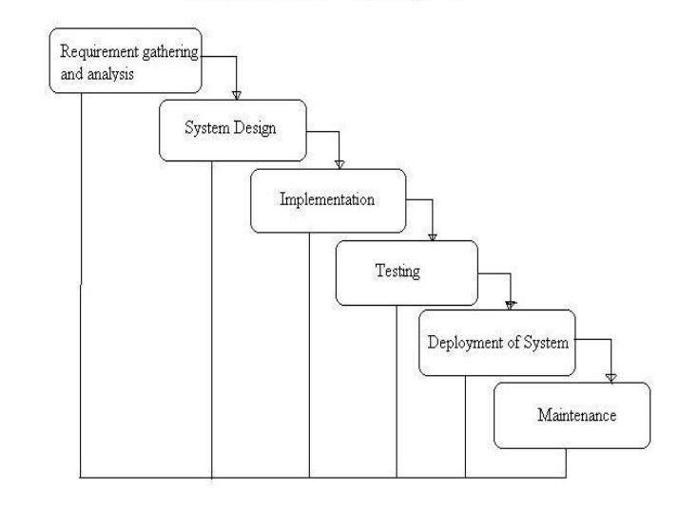

Figure 3.1 : Waterfall model of BMS project.

**3.1.2 Disadvantages of waterfall model:**

* Once an application is in the testing stage, it is very difficult to go back and change something that was not well-thought-out in the concept stage.
* No working software is produced until late during the life cycle.
* High amounts of risk and uncertainty.
* Not a good model for complex and object-oriented projects. • Poor model for long and ongoing projects.
* Not suitable for the projects where requirements are at a moderate to high risk of changing.

##### 3.1.3 When to use the waterfall model

* This model is used only when the requirements are very well known, clear and fixed.
* Product definition is permanent.
* Technology is understood.
* There are no indefinite requirements.
* Sufficient resources with the required expertise are available freely.
* The project is short.

However, very less customer enter action is involved during the development of the product. Once the product is ready then only it can be demoed to the end-users. Once the product is developed and if any failure occurs then the cost of fixing such issues is very high because we need to update everywhere from document to logic.

#### 3.2 Justify chosen methodology

To solve actual problems in an industry setting, a software engineer or a team of engineers must incorporate a development strategy that encloses the process, methods, and tools layers and generic phrases. This strategy is often referred to as a process model or a software engineering instance or project development approach. A process model for software engineering is chosen based on the nature of the project and application, the methods and tools to be used, and the controls and deliverables that are required. This software BMS is based on Waterfall Model. The waterfall model is a simple software development process model that punctuates a long development period. If requirements are well understood and the project scope is awkward, the waterfall process enables a development team to create a “fully functional system” within short time periods. And for this System development which falls within a short period of time, there is no other methodology suitable other than the waterfall model, which is the best approach in producing the expected deliverable Bank Management System (BMS). [6]

#### 3.3 System Requirement Analysis

This includes the development environment and the operating system in which this Bank Customers Management system is built. The capacity of the client and servers and the type of processors required in the hardware to develop this application ranging from front end to back end.

##### 3.3.1 Hardware Requirements

**Processor:** Intel(R) Core

**Installed Memory:** 4.00GB

**Speed:** 1.70GHz or faster

**Operating System:** 64-Bit Operating system, x64-based processor

##### 3.3.2 Software Requirement

**Operating System:** Windows 7,8,10.

**Data Base:** MySQL Server

**Web Server:** IIS (Internet Information Services)

**Web Technologies:** HTML, CSS, BOOTSTRAP, PHP, JAVASCRIPT, JQUERY.

**Client Application:** Internet Explorer, chrome, Mozilla Firefox etc.

### Chapter Four

**System design and development**

A system requirements analysis is a complete description of the conduct of the system to be developed. It includes a set of use cases that describe all of the interactions that the users will have with the system. In addition to use cases, the system requirement analysis contains functional requirements, which define the internal workings of the system: that is, the calculations, technical details, data manipulation and processing, and other specific functionality that shows how the use cases are to be satisfied. It also contains nonfunctional requirements, which impose constraints on the design or implementation (such as performance requirements, quality standards or design constraints). [7]

#### 4.1 Requirement

The requirement is a complete description of the behavior of the system to be developed. These requirements includes functional and non-functional requirements.

##### 4.1.1 Functional Requirement

A functional requirement defines the internal workings of the system: that is, the calculations, technical details, data manipulation and processing, and other specific functionality that shows how the use cases are to be satisfied. The functionalities of the system or modules are mean what the system supposes to do.

###### For Admin Module

1. This system allows the admin to login with an employee id and password.
2. This system allows the admin to create a meeting for development.
3. This system allows the admin to accept or reject a customer.
4. This system allows the admin to approve or reject customer transaction request.
5. This system allows the admin to View Customer’s details.
6. This system allows the admin to reset password if the password is forgotten.

###### For Customer Module

1. This system allows the customer to log in with the account number and password.
2. This system allows the customer to update personal details.
3. This system allows the customer to reset the password if the password is forgotten.
4. This system allows the customer to view his/her account balance.
5. This system allows the customer to transfer money from his account to another account.
6. This system allows the customer to recover the password.
7. This system allows the customer to change the password.
8. This system allows the customer to deposit/withdraw the balance from his/her account.
9. This system allows the customer to choose an image.

##### 4.1.2 Non-Functional Requirement

**A Non-functional requirement** is a requirement that specifies criteria that can be used to judge the operation of a system, rather than specific behaviors. It is about how the system supposes to be and specify the quality of the system, which is mostly related to the satisfactionof the user, for example minimum acceptable page load time. Some of these non-functional requirements are: 1. Integrity

1. Usability
2. Maintainability

**Integrity**: Integrity testing is a type of software testing that is done to check whether the application or the product is secured or not. It checks to see if this application is vulnerable to attacks if anyone hacks the system or login to the application without any authorization. It is a process to determine that an information system protects data and maintains functionality as intended. The security testing is performed to check whether there is any information leakage in the sense of encrypting the application or using a wide range of software and hardware and firewalls etc. For example, this online bank application can allow the users to log in and carry out a transaction but not edit their account balance. As only when a transaction occurs their account balance should be automatically update

**Usability:** This has to do with black-box testing, but relating it to white box testing, usability testing is a very wide area of testing and it needs a fairly high level of understanding of this field along with a creative mind. People involved in usability testing are required to possess skills like patience, ability to listen to the suggestions, openness to welcome any idea, and the most important of them all is that they should have good observation skills to spot and fix the issues or problems.

As soon as the user problems are identified, if such a problem arises from the internal mechanism of the product then the white box testing strategy can help to identify and fix those problems.

**Maintainability**: It defines how easy it is to maintain the system. This means that how easy it is to analyze, change and test the application or product. Maintainability testing shall use a model of the maintainability requirements of the software product. The maintainability testing shall be specified in terms of the effort required to effect a change under each of the following four categories:

1. **Corrective maintenance:** Deals with correcting problems. The maintainability of a system can be measured in terms of the time taken to diagnose and fix problems identified within that system.
2. **Perfective maintenance:** This deals with system enhancements. The maintainability of a system can also be measured in terms of the effort taken to make required enhancements to that system. This can be tested by recording the time taken to achieve a new piece of identifiable functionality such as a change to the database, etc. A number of similar tests should be run and an average time calculated. The outcome will be that it is possible to give an average effort required to implement specified functionality. This can be compared against a target effort and an assessment made as to whether requirements are met.
3. **Adaptive maintenance:** Adapting to changes in the environment. The maintainability of a system can also be measured in terms of the effort required to make required adaptations to that system. This can be measured in the way described above for perfective maintainability testing.
4. **Preventive maintenance**: Actions to reduce future maintenance costs. This refers to actions to reduce future maintenance costs and to maximize profit while reducing cost. It is also important to note that maintainability deals with; modular structure of software, internal program documentation, Programmer’s manual typical requirements, Code to company standards and guidelines. [8]

#### 4.2 System Architecture

##### 4.2.1 Use case Diagram

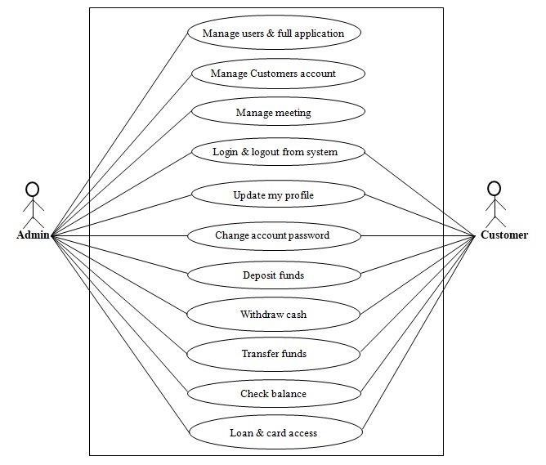

Figure 4.1 : Use case diagram of BMS [9]

##### 4.2.2 Module of project

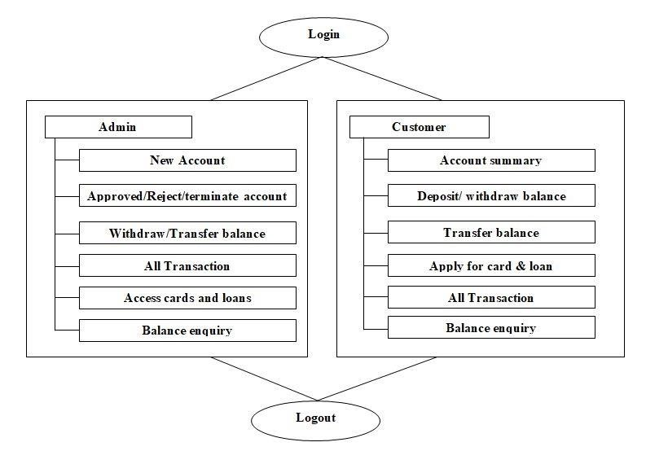

Figure 4.2 : Module of system

#### 4.3 Database Design

The database, called a bank, will have eight tables, those are called registration which for admin registration, customer_accounts which for customer’s account opening, customer_fund for customer’s transaction, payee for the payee account holder, card for customer’s card information, loan and active_loan for customer’s loan information and transaction which for all transaction information. Each will hold information about required fields.[10] Those tables have the following fields:

1. **Admin registration table (registration)**

|  |  |
| --- | --- |
| **Fields** | **Description** |
| employee_id (primary key) | Creates a unique customer id for each new admin. |
| name | Stores the admin name. |
| branch | Stores the branch name. |
| designation | Stores the designation of admin. |
| password | Create the password to login. |
| date_of_birth | Stores the date of birth of admin. |
| address | Stores the address of admin. |
| mobile_no | Stores the mobile no for admin. |
| email | Stores the email of admin. |
| Token | Create the token |
| status | Stores the status |

1. **Customer account opening table (customer_account)**

|  |  |
| --- | --- |
| **Fields** | **Description** |
| customer_name | Stores the customers name |
| date_of_birth | Stores the date of birth of customer. |
| phone_no | Stores phone no of customers. |
| email | Stores the email of customer. |
| address | Stores the address of customers. |
| city | Stores the city of customers. |
| post_code | Stores the post code of customers. |
| gender | Stores the gender of customers. |
| maritial_status | Stores the marital status of customers. |
| religion | Stores the religion of customers. |
| educational_qualification | Stores the educational qualification of customers. |
| citizen | Stores the citizenship of customers. |
| existing_account | Find the existing account of customers. |
| income | Stores the income of customers. |
| account_type | Stores the account type of customers. |
| account_no (primary key) | Create the account no for customers. |
| pin_code | Create the pin code for login. |
| service | Stores the service type. |
| file | Stores the images of customers. |
| token | Create the token. |
| status | Stores the status. |
| otp | Create the otp for customers. |

1. **Customer fund (customer_fund)**

|  |  |
| --- | --- |
| **Fields** | **Description** |
| transection_no (primary key) | Create the transaction no. |
| payee_account_no | Stores the payee account no. |
| account_no (foreign key) | Stores the account no |
| customer_name | Stores the customers name. |
| account_type | Stores the account type |
| term | Stores the terms. |
| amount | Stores the amount of balance. |
| deposit | Stores the amount of deposit fund. |
| transfer | Stores the amount of transfer. |
| withdraw | Stores the amount of withdraw fund. |
| remark | Create the remark for deposit fund. |
| remark1 | Create the remark for transfer fund. |
| remark2 | Create the remark for withdraw fund. |
| branch | Find the branch name. |
| otp | Create the otp for transfer fund. |

1. **Payee account (payee)**

|  |  |
| --- | --- |
| **Fields** | **Description** |
| serial_no(primary key) | Create the serial no. |
| payee_name | Stores payee name |
| payee_account_no | Creates the payee account no. |
| remark | Stores the remark |
| phone_no | Stores the phone no. |

1. **All transaction (transection)**

|  |  |
| --- | --- |
| **Fields** | **Description** |
| transection_id (primary key) | Create the transaction id. |
| date | Stores the transaction date. |
| remark | Stores the transaction type. |
| debit | Stores the fund of debit. |
| credit | Stores the fund of credit. |
| balance | Stores the total balance. |
| phone_no | Stores the phone no |
| term | Stores the terms. |
| deposit | Stores the amount of deposit. |
| transfer | Stores the amount of transfer. |
| withdraw | Stores the amount of withdraw fund. |
| transection_no (foreign key) | Stores the transaction no of customer_fund table. |
| Payee_account_no | Stores the payee account no. |

1. **Cards information (card)**

|  |  |
| --- | --- |
| **Fields** | **Description** |
| s_no (primary key) | Create the serial no. |
| account_no (foreign key) | Stores the account no. |
| card_no | Create the card no |
| card_type | Stores the card type |
| card_limit | Stores card limitation of balance. |
| apply_date | Stores the card application date. |
| remark | Create the remark for card |
| status | Stores the status of card application. |

1. **Loan information table (loan)**

|  |  |
| --- | --- |
| **Fields** | **Description** |
| serial_no (primary key) | Creates the serial no of loan. |
| customer_name | Stores the customers name |
| f_name | Stores the father’s name |
| m_name | Stores the mother’s name. |
| date_of_birth | Stores the date of birth of customer. |
| pre_address | Stores the present address of customers. |
| per_address | Stores the permanent address of customers. |
| phone_no | Stores phone no of customers. |
| email | Stores the email of customer. |
| gender | Stores the gender of customers. |
| maritial_status | Stores the marital status of customers. |
| education | Stores the educational background of customers. |
| occupation | Stores the occupation of customers. |
| income | Stores the income of customers. |
| gurantor_name | Stores the gurantor’s name. |
| g_occupation | Stores the occupation of gurantor’s. |
| g_address | Find the address of gurantor’s. |
| g_file | Stores the image of gurantor’s. |
| account_no | Stores the account no for customers. |
| loan_type | Stores the loan type |
| term | Stores the terms |
| Amount | Stores the amount of loan |
| appli_file | Stores the applicant photos. |
| bill_file | Stores the electricity/gas bill copy. |
| apply_date | Stores the application date |
| status | Stores the status. |

1. **Loan activation (active_loan)**

|  |  |
| --- | --- |
| **Fields** | **Description** |
| sl_no (primary key) | Create the serial no. |
| serial_no (foreign key) | Stores the serial no from loan table. |
| loan_type | Stores the loan type. |
| amount | Stores the loan amount |
| strat_date | Creates the loan application date |
| end_date | Creates the deadline of loan |
| duration | Stores the duration of loan |
| interest_rate | Creates the interest rate of loan |
| payable_amount | Creates the payable amount |
| emi_m | Stores the emi in monthly |
| emi_q | Stores the emi in quarterly |
| emi_y | Stores the emi in yearly |
| status | Stores the status of loan application. |

### Chapter Five

**Project Screenshot and Description**

This project is based on PHP, HTML language, Javascript, JQuery, Bootstrap, and MYSQL use for information base organization. Making, and supervision prerequisites is a test of IT, frameworks and item improvement risk or in fact for any activity where you need to deal with an authoritative relationship. [11] Organizations need to sufficiently differentiate and supervise necessities to guarantee they are addressing the requirements of the customers while publishing consistency and remaining on the timetable and inside spending plan. It considers other related frameworks and in the future think of framework determinations. The framework is then planned as per details to fulfill the prerequisites. The framework configuration is then executed with MYSQL, PHP, HTML, BOOTSTRAP, JAVASCRIPT, and JQUERY. The framework is planned as an intelligent and imports the executive’s framework. Import the board framework manages information section, approval affirms and refreshing whiles the intelligent framework manages framework help with the organization and clients. [12]

Thus, the above features of this task will save transaction time and therefore increase the efficiency of the framework.

#### 5.1 Figures of BMS

This project is mainly divided into two modules such as admin module and the customer module.

In admin module, it represents how to access all employee’s details and customer’s transaction such as deposit/transfer/withdraw balance, customer’s account, loan, and card information, in admin module HR department create a meeting for developing management system (if necessary) and sent to meeting link to all employees. In the customer module it represents how the customers are transacting with the bank, they can create a transaction of deposit/transfer/withdraw an amount from his account and can see their individual transaction reports, also can apply for card and loan. Consequently, the above features of this task will save transaction time and accordingly increment the efficiency of the framework. [13] [14] Now we discuss all parts step by step.

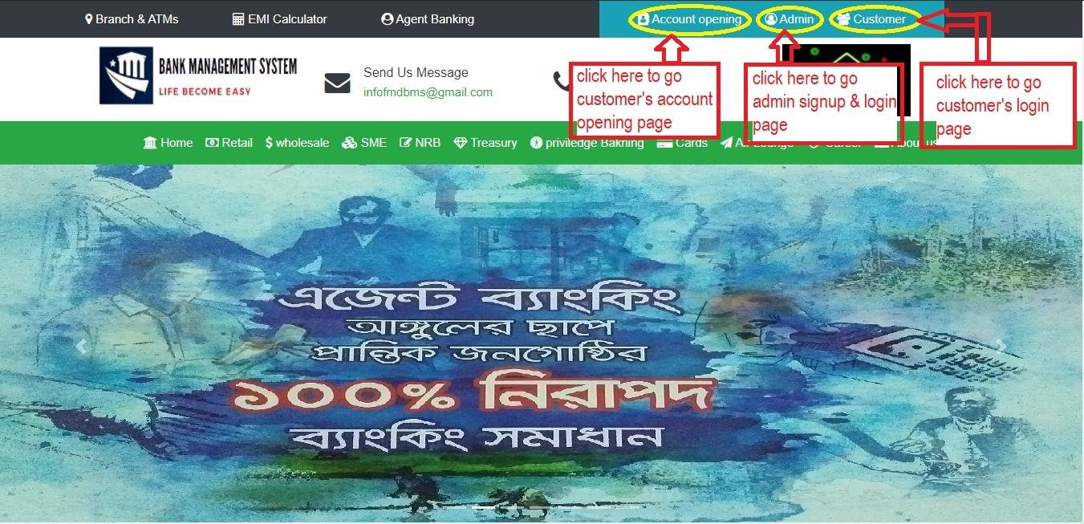

Figure 5.1 : home page of banking management system

#### 5.2 Admin login section

First of all, you have to create an account with all valid information, and then verify your account to log in using the verification link sent by email. If the account is not verified then will display an error that “Please Verify Your Email Account”. And if it is verified then the system will check your employee id and password to logged in if the id and password don’t match then will show an error “your user id or password is incorrect”. if all data is correct then you can be logged into your account. This process is shown below-

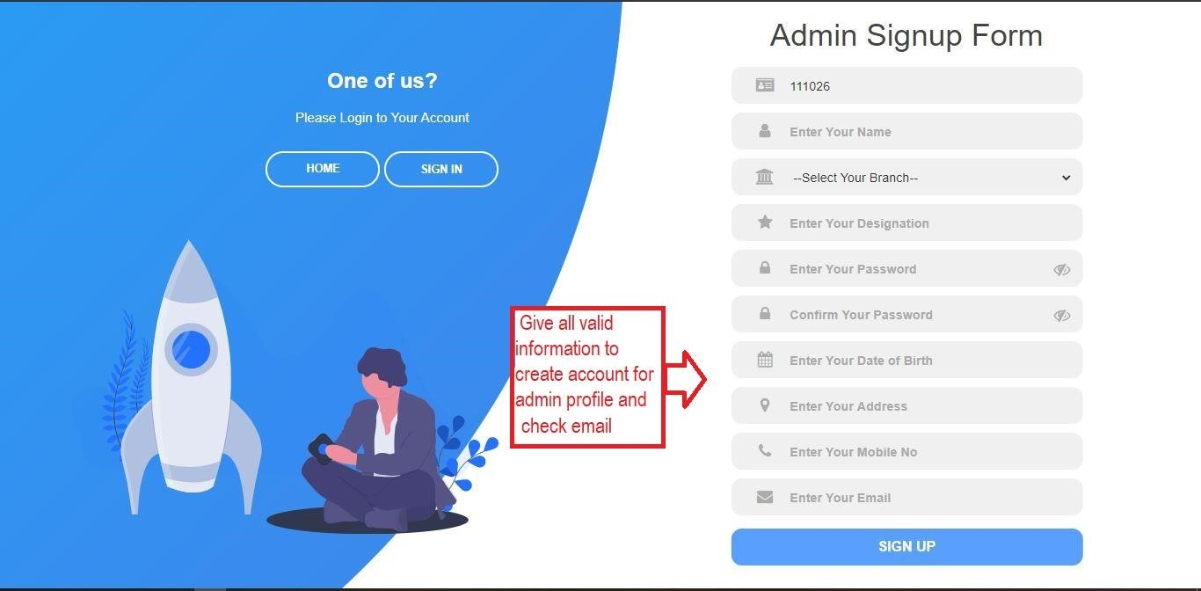

Figure 5.2 : admin account opening form.

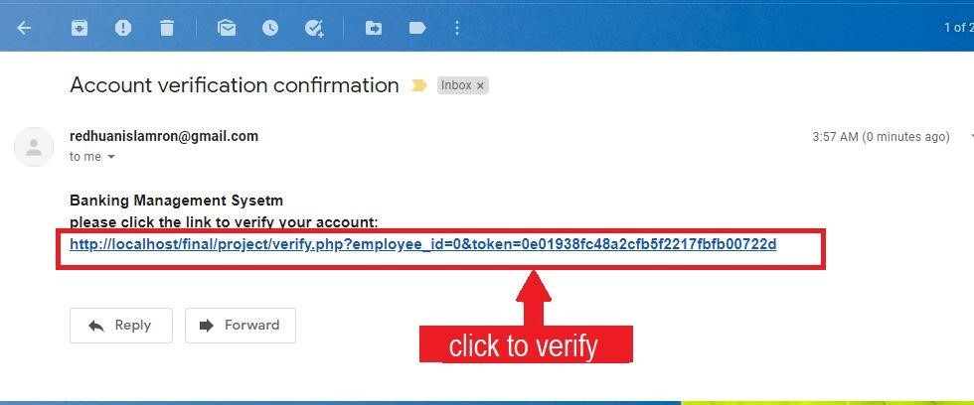

Figure 5.3 : admin account verification link.

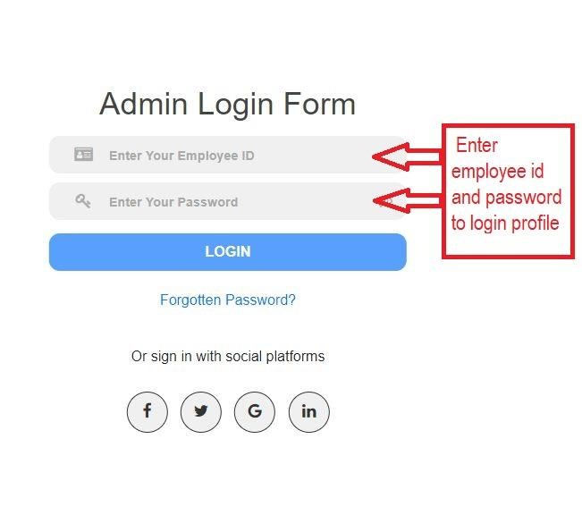

Figure 5.4 : admin login option.

##### 5.2.1 Admin Profile

In admin module, it represents how to access all employee’s details and customer’s transaction such as deposit/transfer/withdraw balance, customer’s account, loan, and card information, in admin module HR department create a meeting for developing management system (if necessary) and sent to meeting link to all employees. It is used to keep the records of customers, employees, etc. in Bank. The bank management system is an application for managing a personal account in a bank. The framework pronounces the admittance to the customer to create an account, deposit/withdraw the cash from his account, also to view reports of all accounts present. The following presentation declares the specification for the system. After logged into the employee profile in the dashboard it has shown some modules such as accounts, loan, cards, and transactions. In accounts section displayed all accounts information which are new account request, approved account information, reject account information, terminated account information. In loan section displayed new loan request information and all inserted loan details. In card section displayed all card information. In transaction part displayed all kinds of transactions such as deposit amount, transfer amount, withdrawal amount. Employee’s dashboard profile shown below-

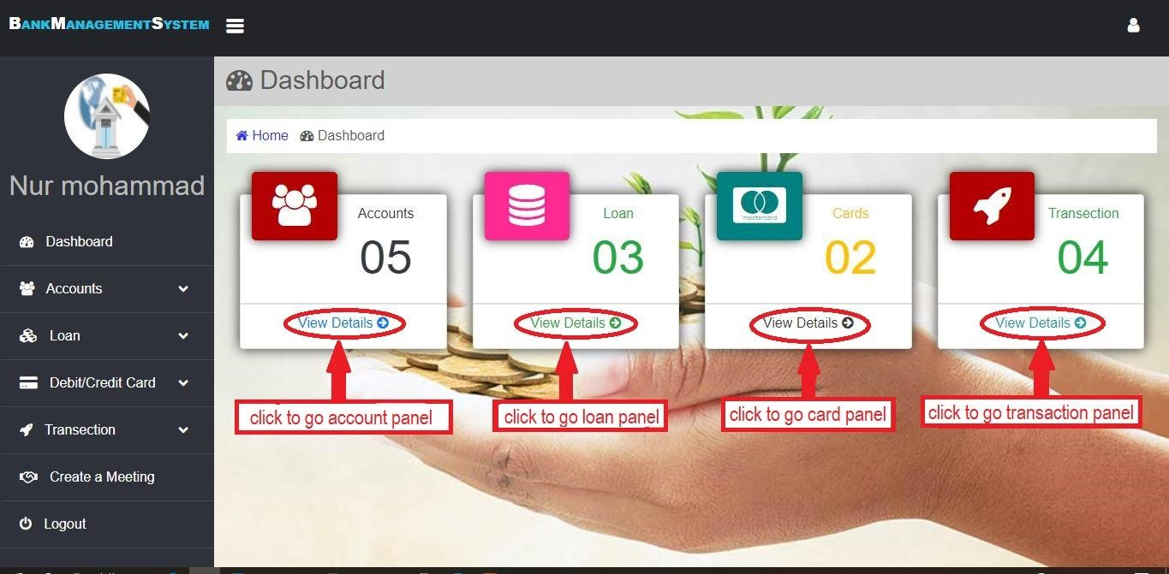

Figure 5.5 : Employee’s dashboard profile.

##### 5.2.2 Admin access to Customer account

In this section from the dashboard, we have to go accounts module and there displayed some part such as account request, account details, approved account, reject account and terminate account. For opening a new account customer has to apply online by giving the required information. After applying for opening new account a new account request will appear in the admin account. Admin will see all the details giving by the customer and there will three options “Approved ”,”

Rejected” & “Terminated”. Admin will decide to approve it or reject or terminate it. If an admin approved someone's account then he will get an email from bank that is "your account is active you can now login to your account". The process of rejected account and terminated account are same here to send an email, for reject account customer will get the email that is "your account has been rejected please try again with valid information", and for terminated account customer will get an email that is "your account is terminated you can't opening any account again". All of those processes are shown below-

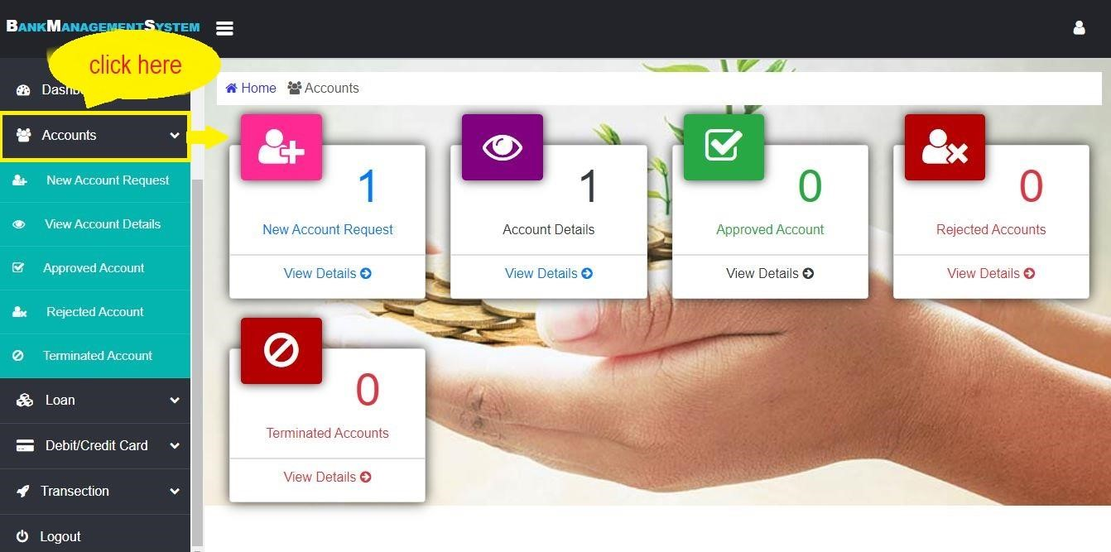

Figure 5.6 : Customer account details

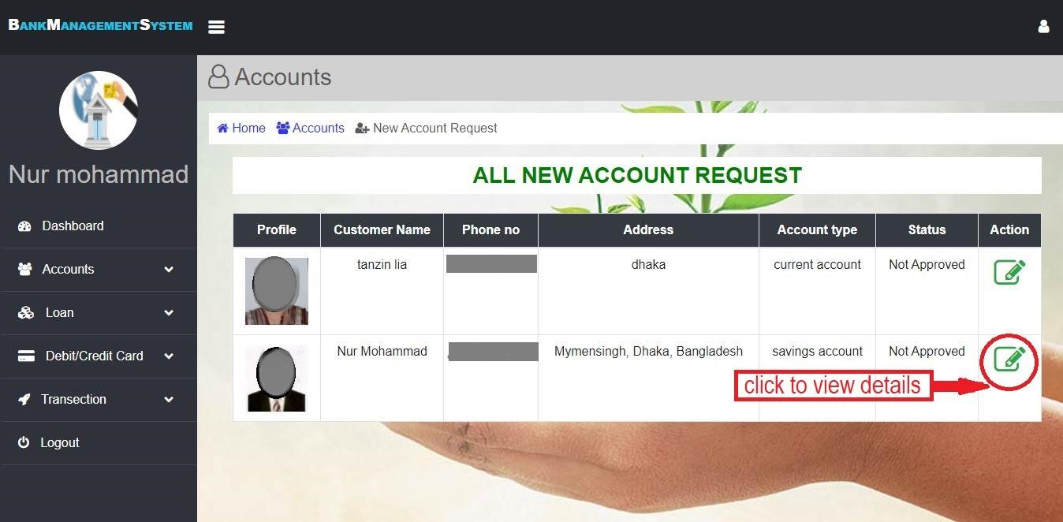

Figure 5.7 : Customer account list

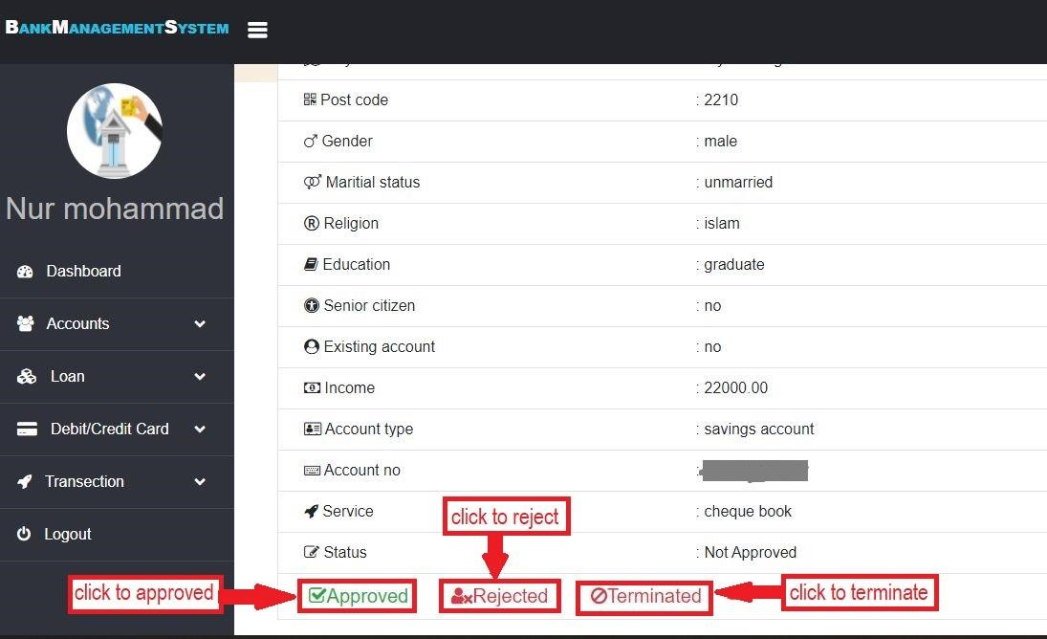

Figure 5.8 : Customer’s personal information

##### 5.2.3 Customer loan access by admin

In this section from the dashboard we have to go loan module and there displayed some part such as active loan, loan request and all loan. After seeing a loan request admin will check all the details provided by the customer. By verifying all the information is true and eligible for the giving the loan admin will approve it. By approving the loan customer will do further formality and if admin feels to not to give the loan then he/she will not approve it. This process is shown below-

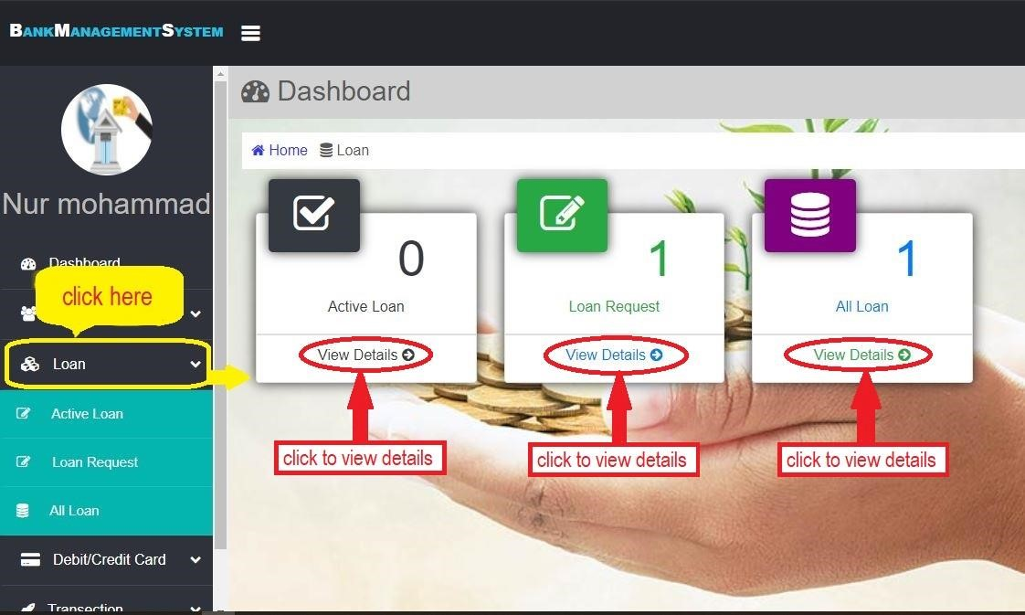

Figure 5.9 : Loan section

After applying for loan a new loan request will appear in loan section. Admin will see all the details giving by the customer and there will two options “Accepted ” & “Rejected”. Admin will decide to sanction it or reject it. If admin sanctioned someone's loan then he will get an email from bank that is "your loan application is accepted". The process of rejected loan is same here to send an email, for reject loan customer will get the email that is "your loan application has been Rejected. All of those processes are shown on above figure 5.8

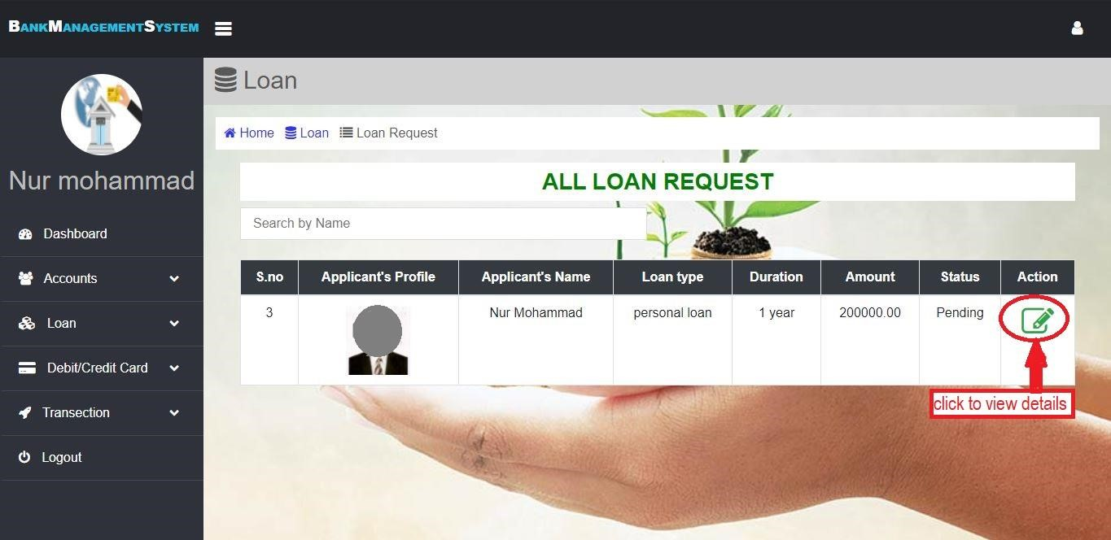

Figure 5.10 : customer loan list

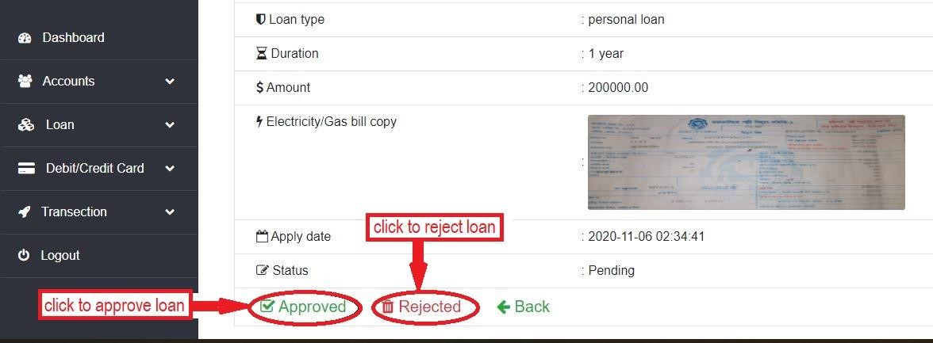

Figure 5.11 : customer loan details

##### 5.2.4 Handling process of Card by Admin

In this section from the dashboard we have to go card module and there displayed two part such as card request and all cards. Here card request option will appear and by seeing all the details of customer provided in application form admin will decide to approve it or not. By approving the request, a mail will be sent to customer to receive the card in giving date. And by not approving the request it will remain pending. This process is shown above (figure 5.11).

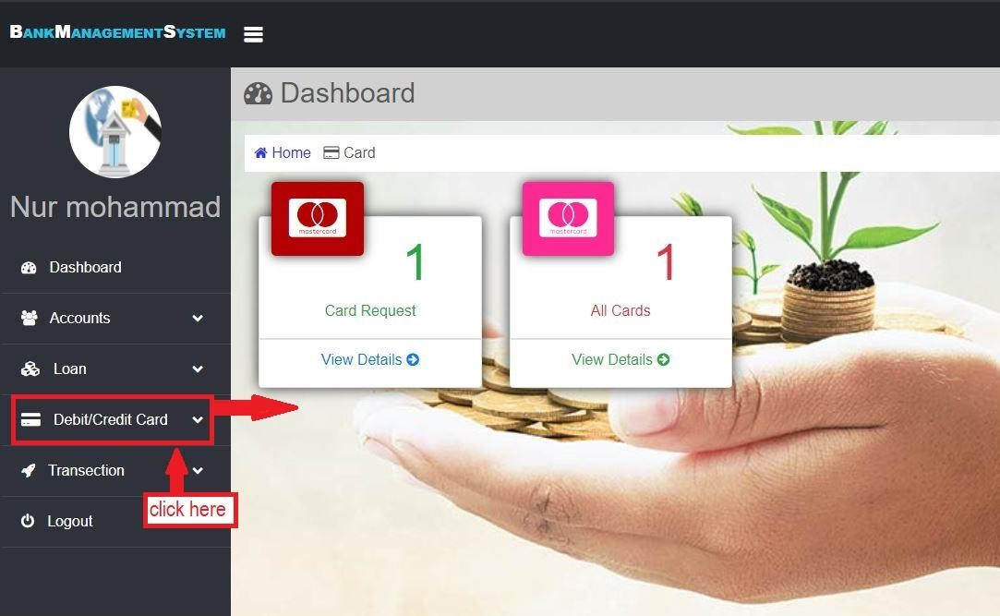

Figure 5.12 : Card section.

After applying for card a new card request will appear in card section. Admin will see all the details giving by the customer and there will a option “Approved”. Admin will decide to accept the card application. If admin accepted someone's card application then he will get an email from bank that is "your card is ready". This process is shown below (figure 5.13).

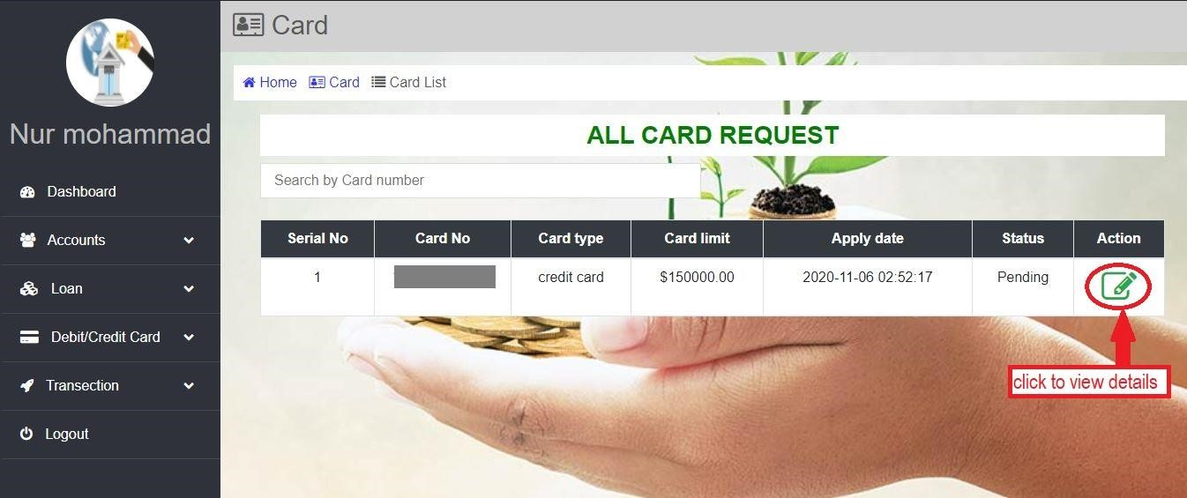

Figure 5.13 : card request list

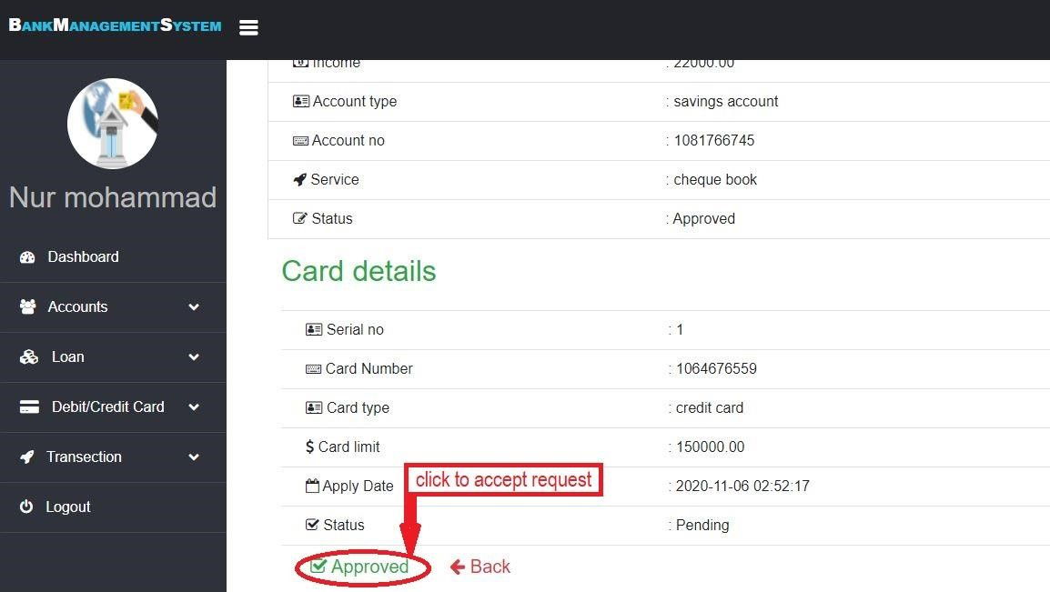

Figure 5.14 : card request details

##### 5.2.5 Customer Transaction access by admin

In this section from the dashboard we have to go transaction module and there displayed four parts such as check deposit, check transfer, check withdrawal and statement. After applying for deposit fund this data will appear in check deposit section, and applying for transfer fund this data will appear in check transfer section, and withdrawal data will appear in check withdrawal section and all data will appear in statement. Transaction part is shown above (figure 5.14)-

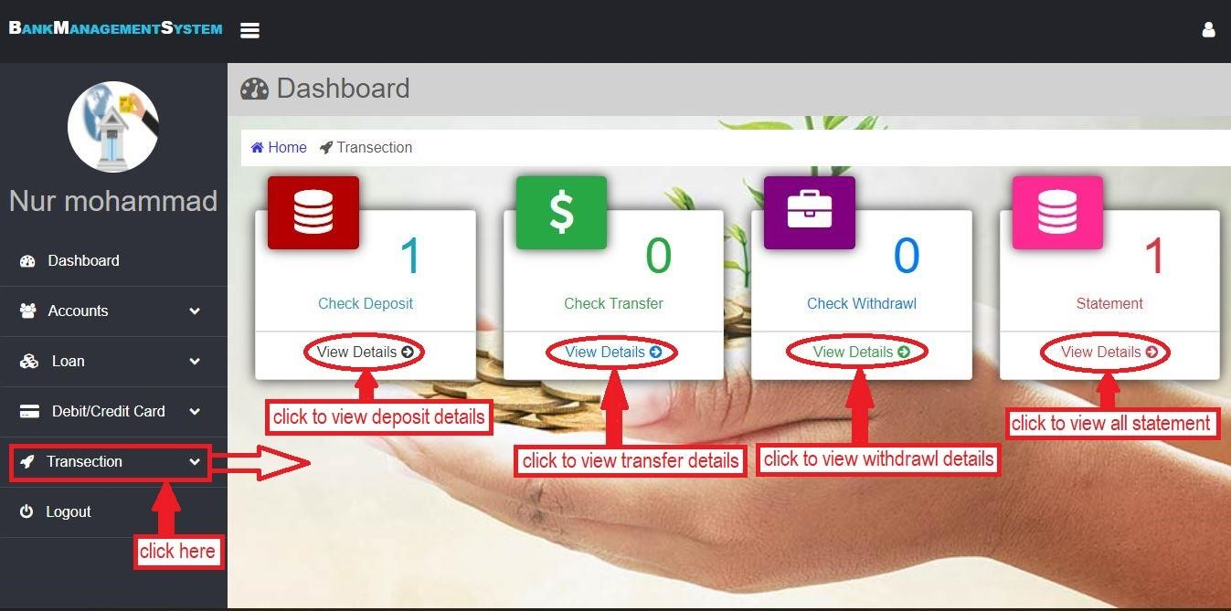

Figure 5.15 : Admin transaction section.

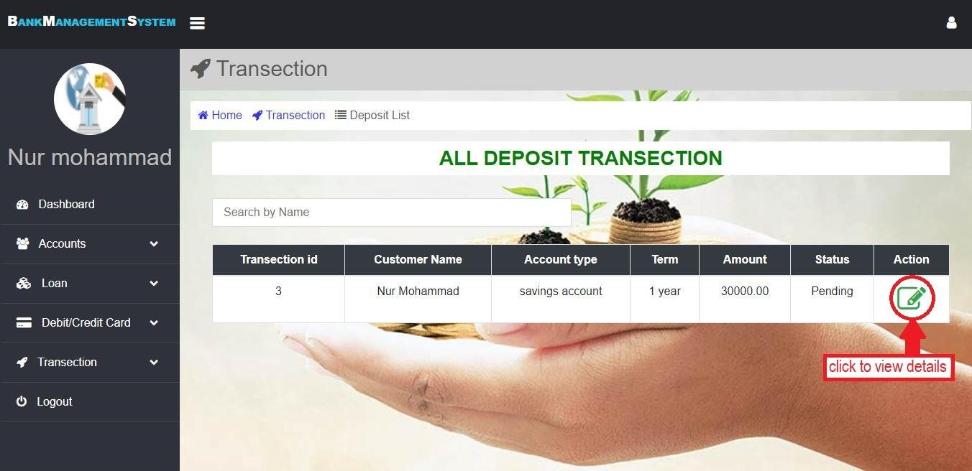

Figure 5.16 : Deposit list.

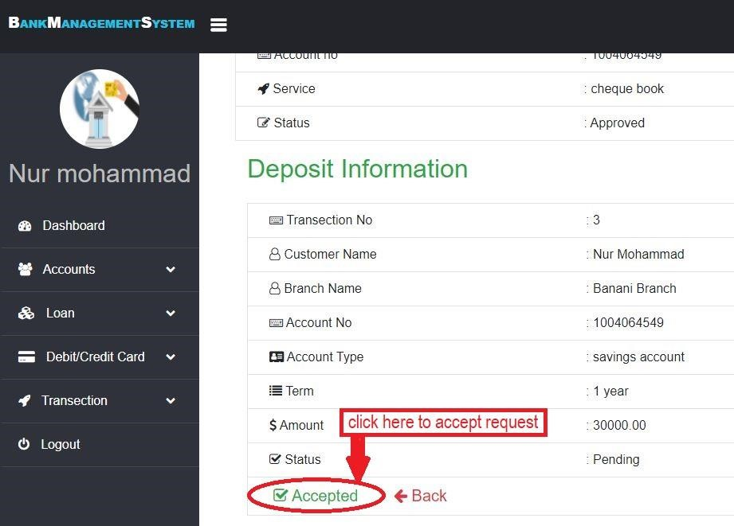

Figure 5.17 : Customer deposit details.

##### 5.2.6 Management meeting create

Each bank needs to make their branches more profited and efficient, yet there are innumerable factors that go into the most straightforward approach to accomplish these objectives is to actualize lining and planning programming to all the more likely address the issues of a bank's customers and representatives. It's easy to schedule a meeting with all employees. In this module HR department create a meeting for developing management system (if necessary) and sent to meeting link to all employees. An employee after logged into his account, he can see an option that is "create a meeting". After clicking this button there will be displayed a form interface which has a meeting date, meeting day, time and meeting link, then giving all provided information and sent to all employee's Gmail. This process is shown below (figure 5.18)-

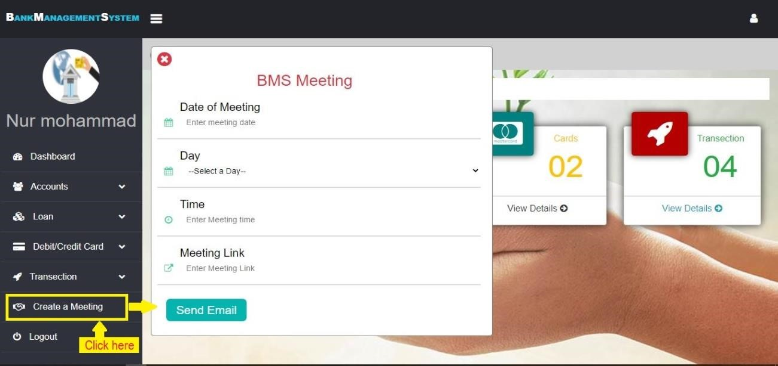

Figure 5.18 : create a meeting

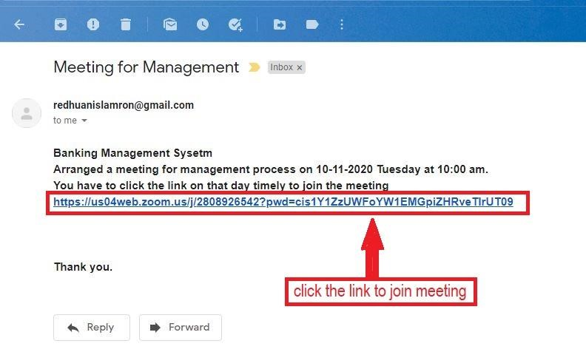

Figure 5.19 : created meeting link to gmail.

##### 5.2.7 View & Update employee profile

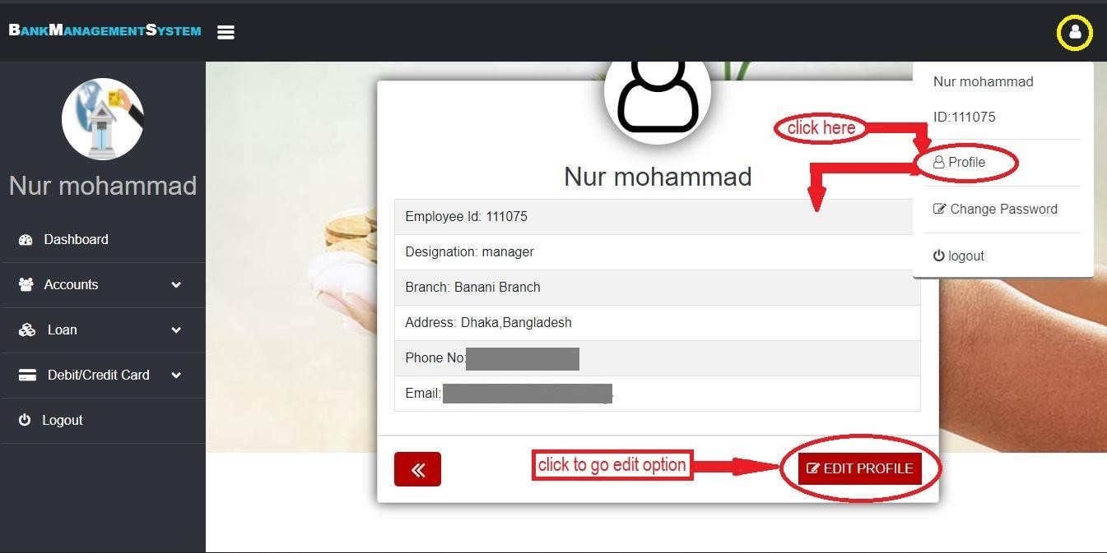

Figure 5.20 : view employee profile

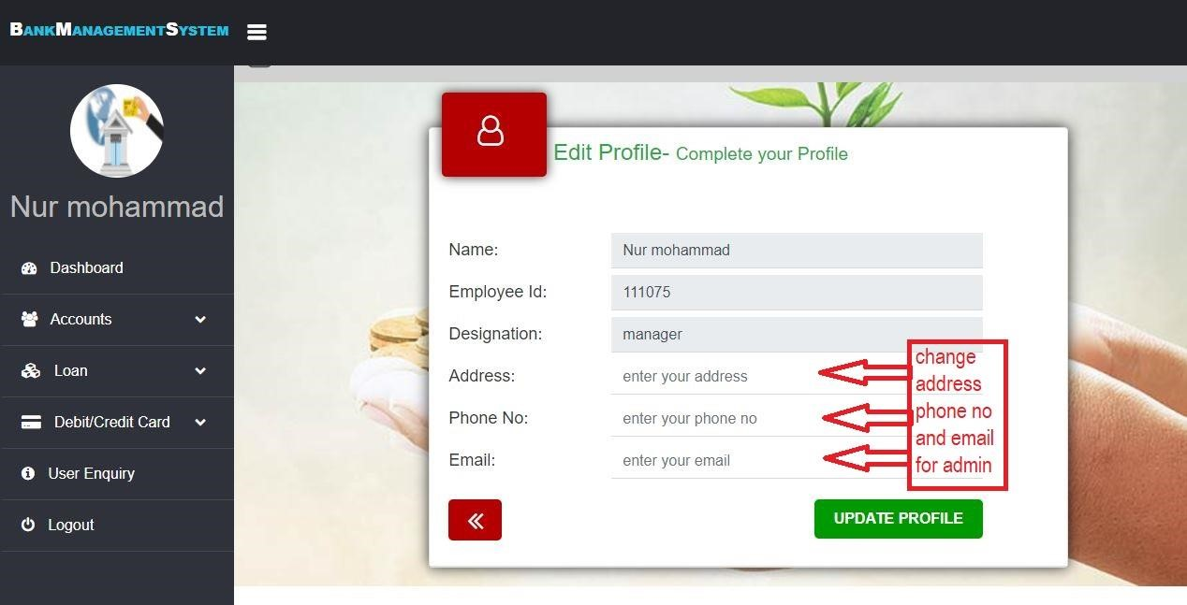

Figure 5.21 : update employee profile

If employees want to change their profile they can do it. After logged into their accounts a user icon will be shown at the right top. After clicking this icon here will be displayed some option such as profile, change password and logout. Click the profile button to update your profile. This procedures is shown on above figure 5.19 & 5.20.

##### 5.2.8 Password change and logout from admin account

If employees want to change their login password they can do it. After logged into their accounts a user icon will be shown at the right top. After clicking this icon there will be displayed some options such as profile, change password and logout. Click the button which name is change password to change your login password. And logout from their accounts using session destroy. Those procedures are shown below (figure 5.22 & 5.23)

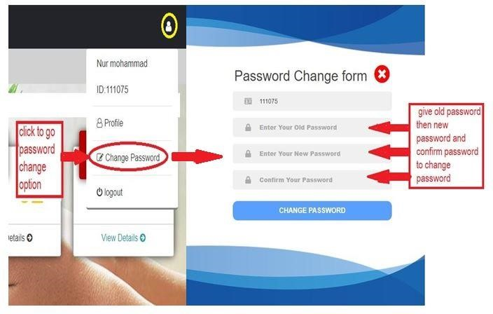

Figure 5.22 : Employee password change form.

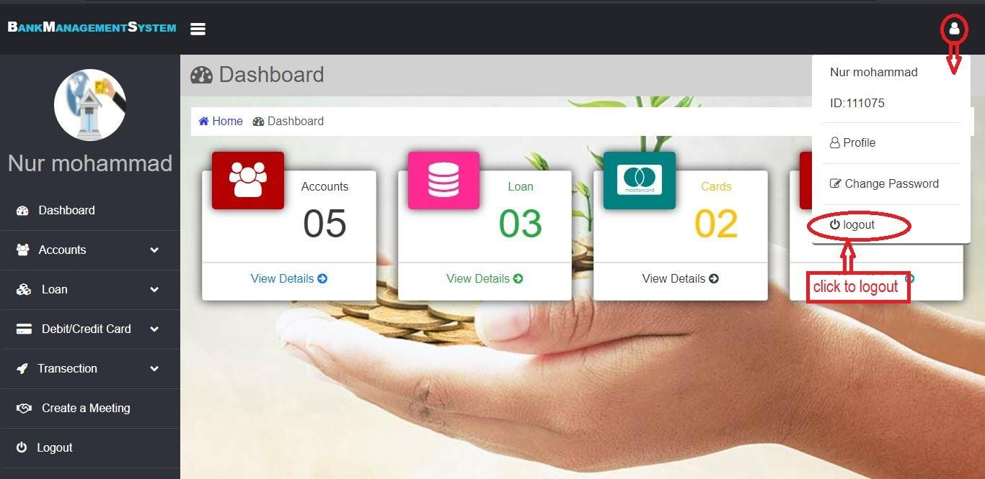

Figure 5.23 : logout option in admin portal.

##### 5.3 Customer Account opening Section

For customer login first of all he/she needs to open an account. By giving all the required information you have to open your bank account, you have to use a unique phone no, unique and valid email address. If you have any existing account then you can’t open new account with those same information in that case you have to recover your existing account. After creating your account this data is stored in the bank database. And then the admin can see your all information and they will decide to action about your account. And admin needs to approve his/her account to make the status active in the database. Otherwise, it will be inactive. By opening an account customer will get an account number and a password. When admin will approve customer's account only that time customers can log in. An error will be displayed during login if a customer's account is rejected and terminated by the admin. Now when a customer will go for login first of all in a box account number and password will be asked. If the status is active and the account number and password matched with database only then the customer can login successfully. Otherwise an error display will be occurred. Account opening process is shown below-

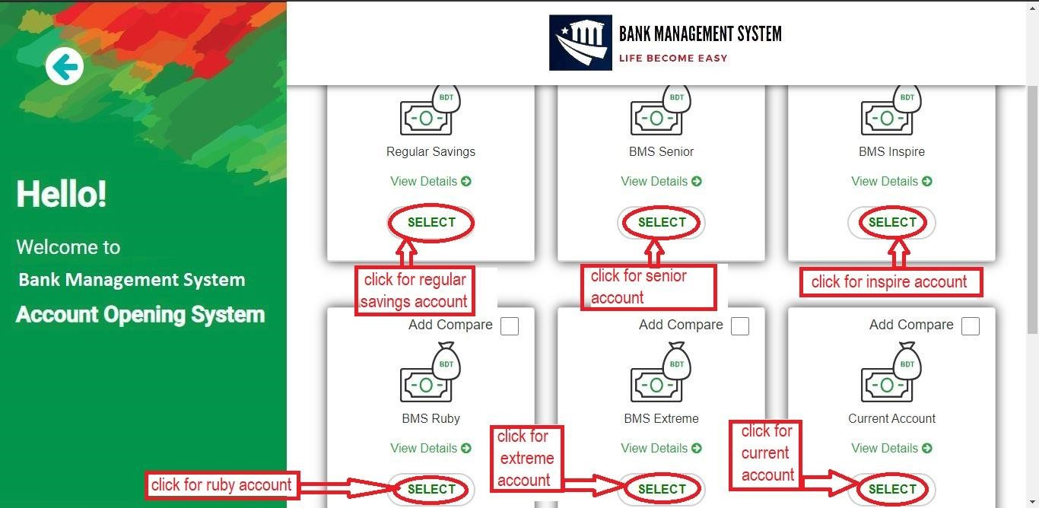

Figure 5.24 : all type of accout

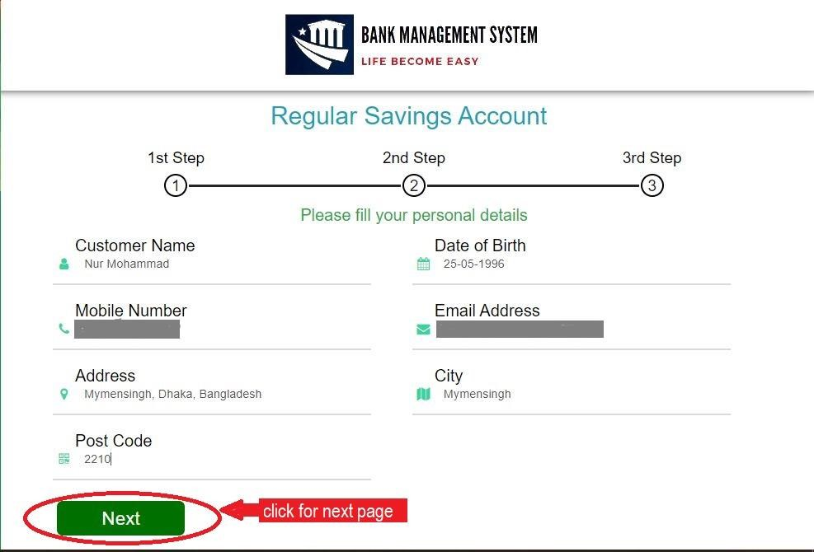

Figure 5.25 : customer account opening form (first part).

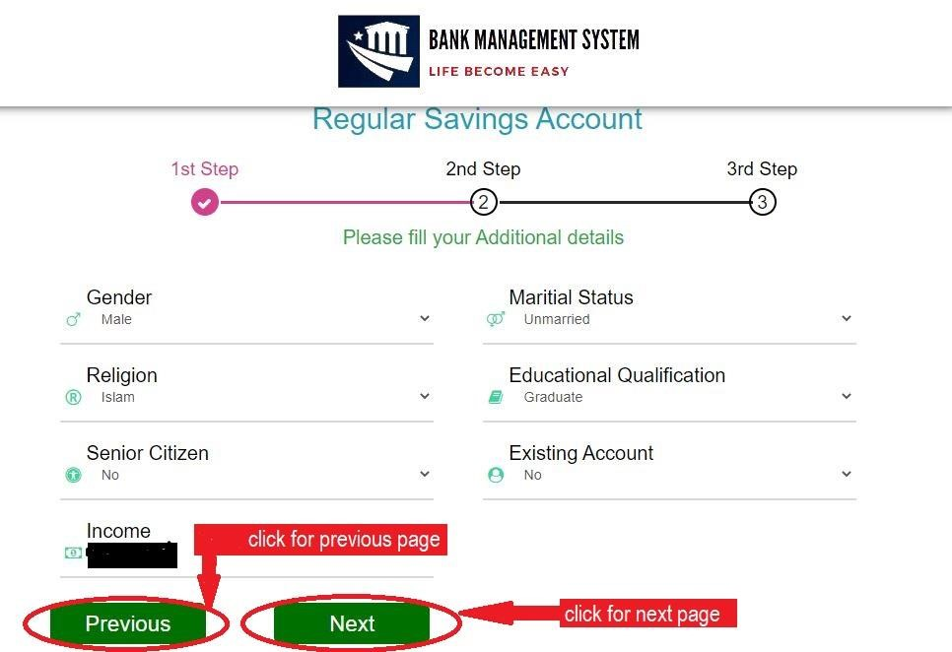

Figure 5.26 : customer account opening form (second part).

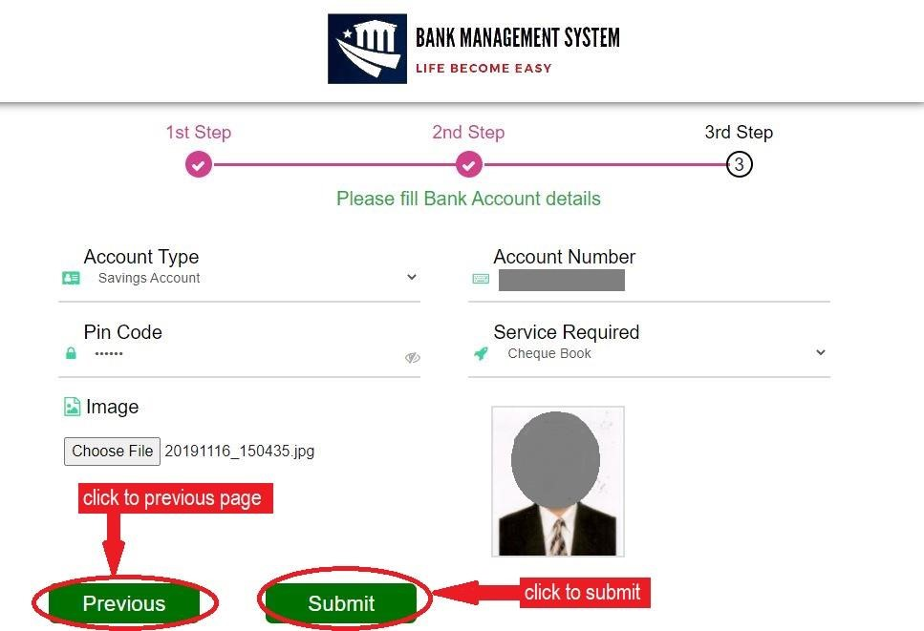

Figure 5.27 : customer account opening form (third part).

###### 5.3.1 Customer Login Section

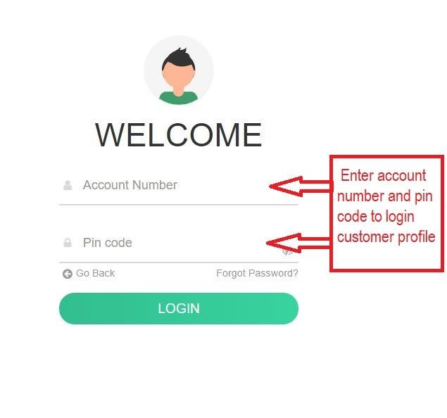

Figure 5.28 : customer login form.

5.3.1.1 Customer recover password section

If you forgot your password you can retrieve it using gmail address. In that case you have to click forgotten password in login section, then you have to give your gmail address which is used during your account opening. After submitting gmail address you will get a password recover link. By clicking this link you will go to password recover form and can change your password. Same process for admin recover password. This process is shown in below (figure 5.29, 5.30, 5.31 and 5.32)

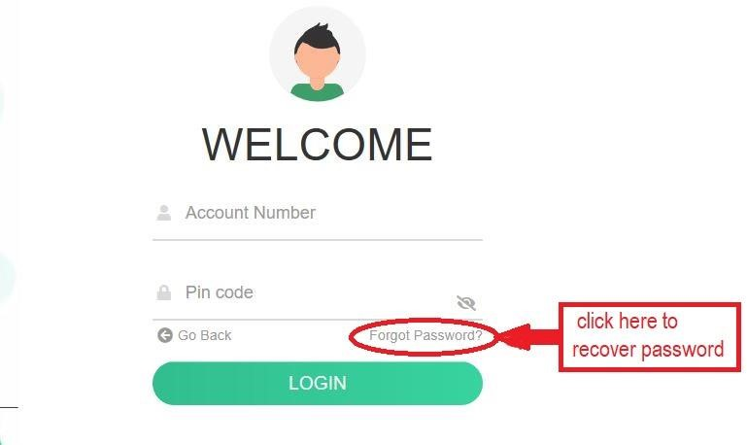

Figure 5.29 : customer retrieve password option (part one).

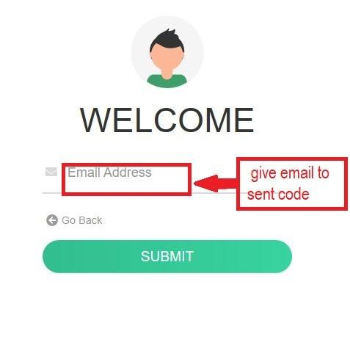

Figure 5.30 : customer retrieve password option (part two).

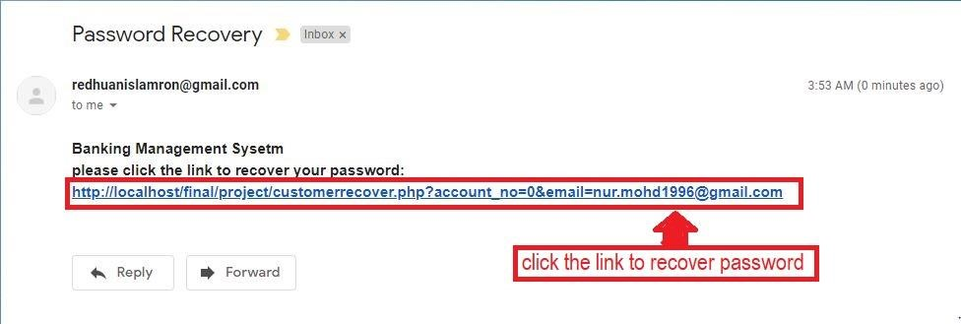

Figure 5.31 : customer retrieve password option (part three).

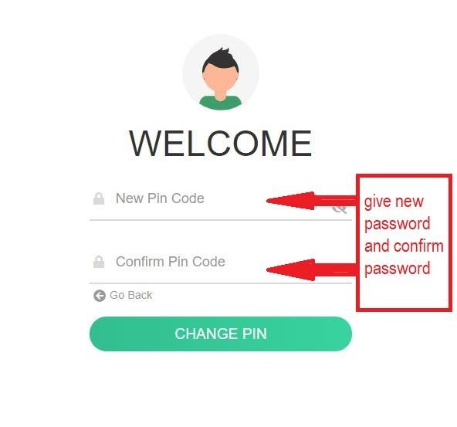

Figure 5.32 : customer retrieve password option (final part).

###### 5.3.2 Customer Dashboard

After login as a customer you will see a dashboard in which displayed your profile, current available balance, update profile, change password, deposit fund, transfer fund, withdraw fund, loan apply section, card apply section and your all transaction statement. You can change your password from change password option, you can update your profile if you want. You can also create all type of transaction from your account. All process we have described step by step.

Dashboard is shown below (figure 5.33)-

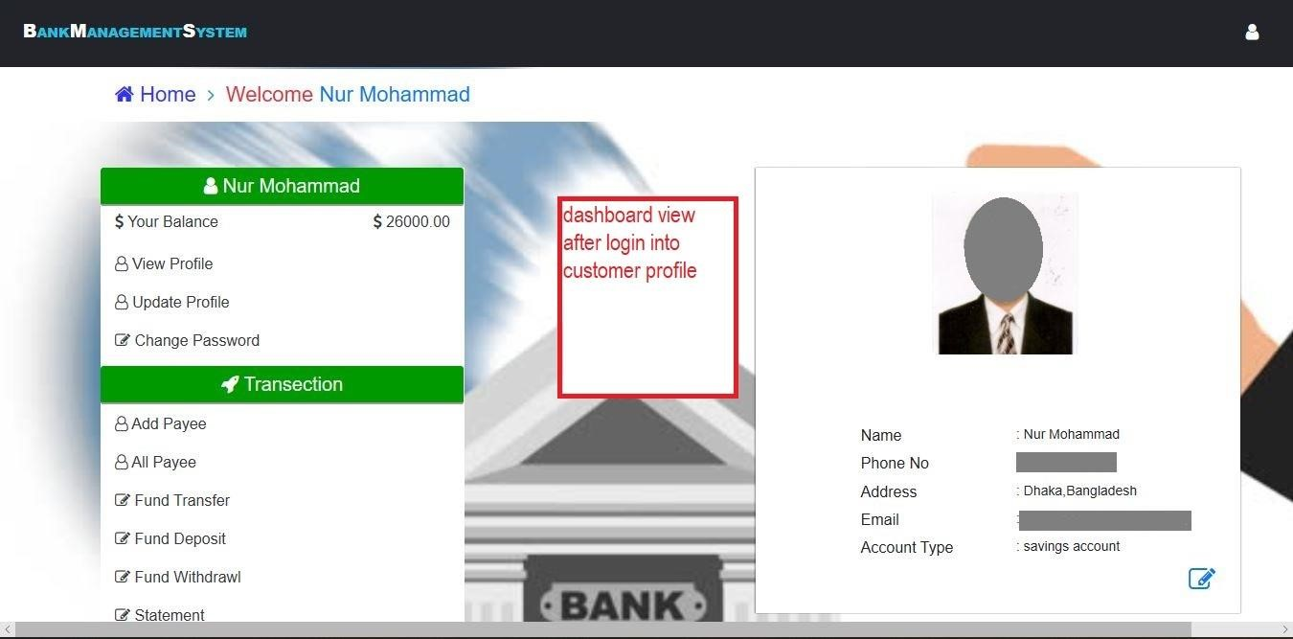

Figure 5.33 : Customer dashboard

###### 5.3.3 Customer Deposit fund

In customer deposit section, from customer dashboard customer will go to ‘Fund Deposit’ section. Then a form will be shown in which customer needs to give some information like

‘Customer Name’ ‘Branch’ ‘Account Number’ ‘Term’ ‘Amount’. After filling this form if all information is valid then deposit fund will be successfully stored in bank database and if there is any invalid information then an error display will occur. After successfully send the deposit request to bank if admin approve the request then your balance is added to your main account otherwise it will be pending. Deposit process is shown in below (figure 5.34)-

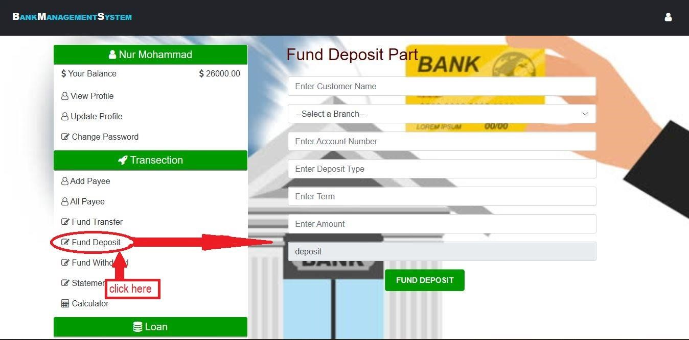

Figure 5.34 : Customer deposit fund

###### 5.3.4 Customer Transfer fund

For customer fund transfer customer will go to ‘Fund Transfer’ section some information will be asked to the customer like ‘Account Number’ ‘Name’ ‘Payee Account Number’ & ‘Amount’.

After giving all information correctly customer needs to click on the final button ‘Transfer Amount’. Then an otp code will be sent to the customer mobile number which is used during account opening. After giving that number database will check if the given information is valid or not and the otp code is matched or not. If yes then transfer will be successful and you will be notified by sending mail otherwise error display will occur. This process is shown below with flowchart (figure 5.36, 5.37, 5.38)-

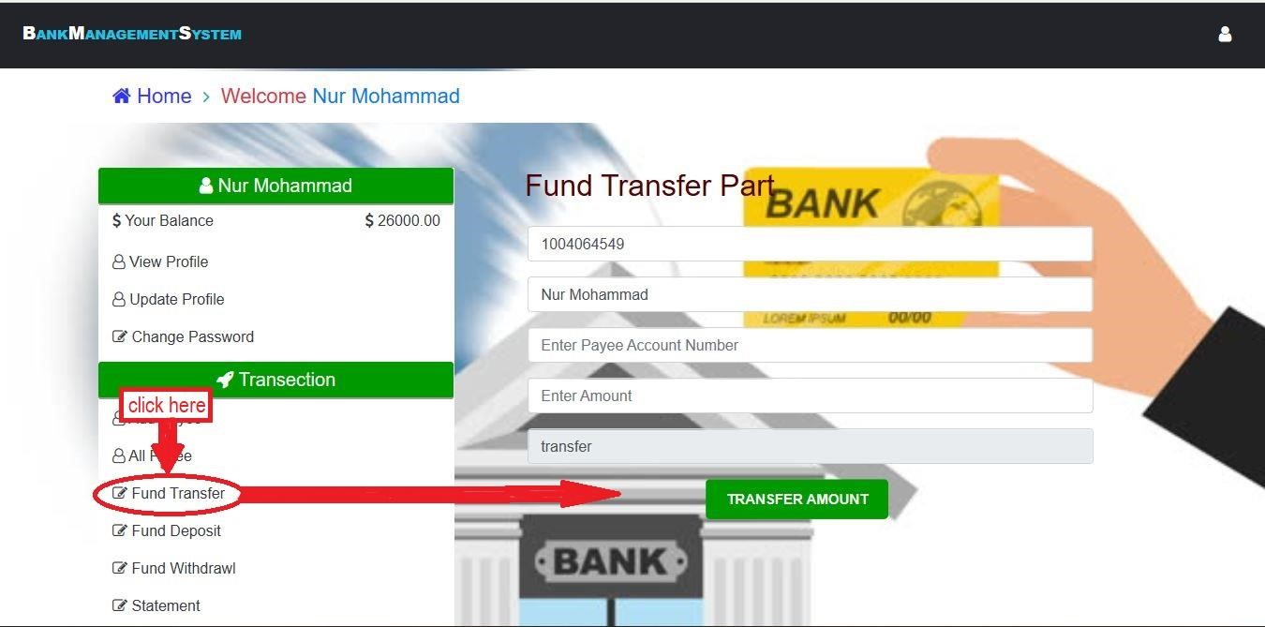

Figure 5.36 : Customer transfer fund (part one).

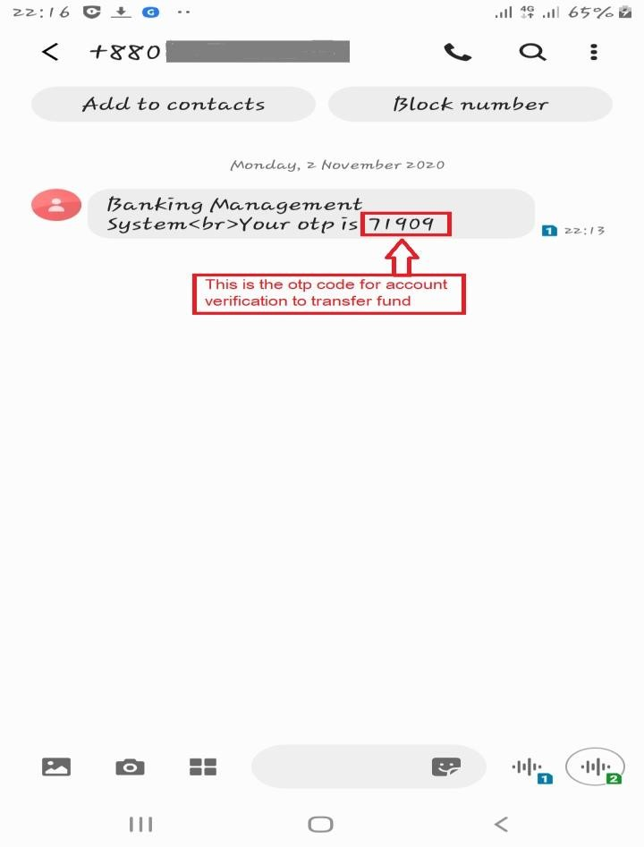

Figure 5.37 : Customer transfer fund (part two).

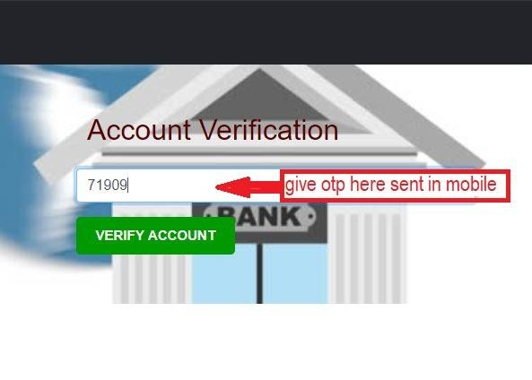

Figure 5.38 : Customer transfer fund (part three).

###### 5.3.5 Customer Withdrawal fund

For customer withdrawal part customer needs to sign in to his/her account. Then in fund withdrawal section some information is needed like ‘Customer Name’ ‘Branch’ ‘Account Number’ ‘Phone Number’ ‘Amount’. After this transaction if all information is valid then request will be submitted successfully and information will be stored in bank database. When admin approved the withdrawal request customer can take the money from bank. By giving any invalid information error display will be occurred. Withdrawal process is shown in below with flowchart (figure 5.39)-

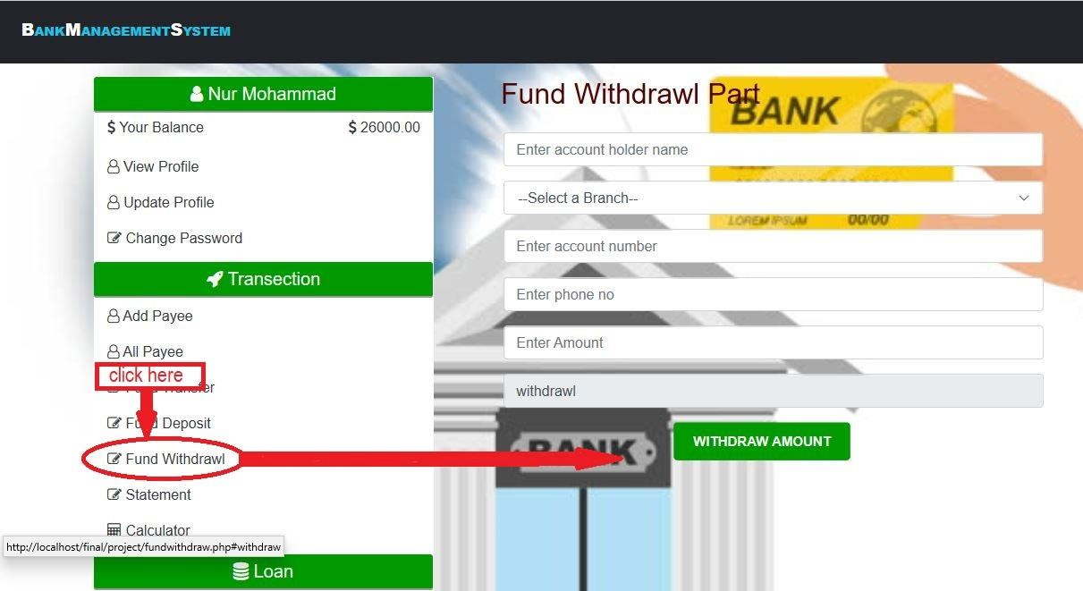

Figure 5.39 : Customer withdrawal fund.

###### 5.3.6 Customer statement

After applying for deposit fund, transfer fund and withdrawal fund all transaction will be displayed in customer statement section. You can remove your transaction from statement. This process is shown in below (figure 5.40)-

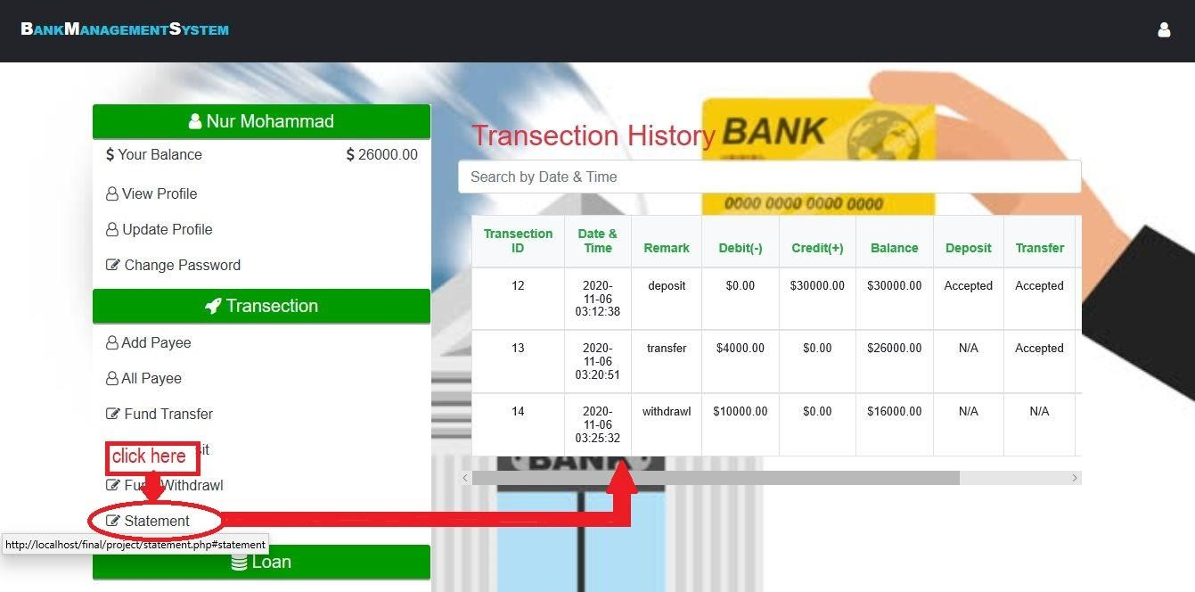

Figure 5.40 : All transaction details

###### 5.3.7 Customer Loan section

To apply for loan online customer will sign in to his/her own account. Then in 4 steps further procedure will be done. In 1st step some information is required like “Name, Father’s Name,

Mother’s Name, Date of Birth, Present Address, Permanent Address, Phone Number, Email Address” then a button named ‘Next’ need to be selected. Then in 2nd step “Gender, Marital status, Educational qualification, Occupation, Income” then again the button named ‘Next’ need to be selected. Then in 3rd step **“**Guarantor’s Name, Guarantor’s Occupation, Guarantor’s Address, Guarantor’s Photo” information needs to be added. Then in 4th and last step “Account Number, Loan Type, Loan Term, Loan Amount, Applicant’s Photo, Electricity/Gas bill Copy” need to attach. After giving all the valid information loan request will be successfully proceeding and all data will be stored in bank database. Otherwise an error display will occur. After seeing this loan request by an admin he can decide to your application. If all of your information is valid and legal then admin can sanction your loan if he want. Loan process is shown in below-

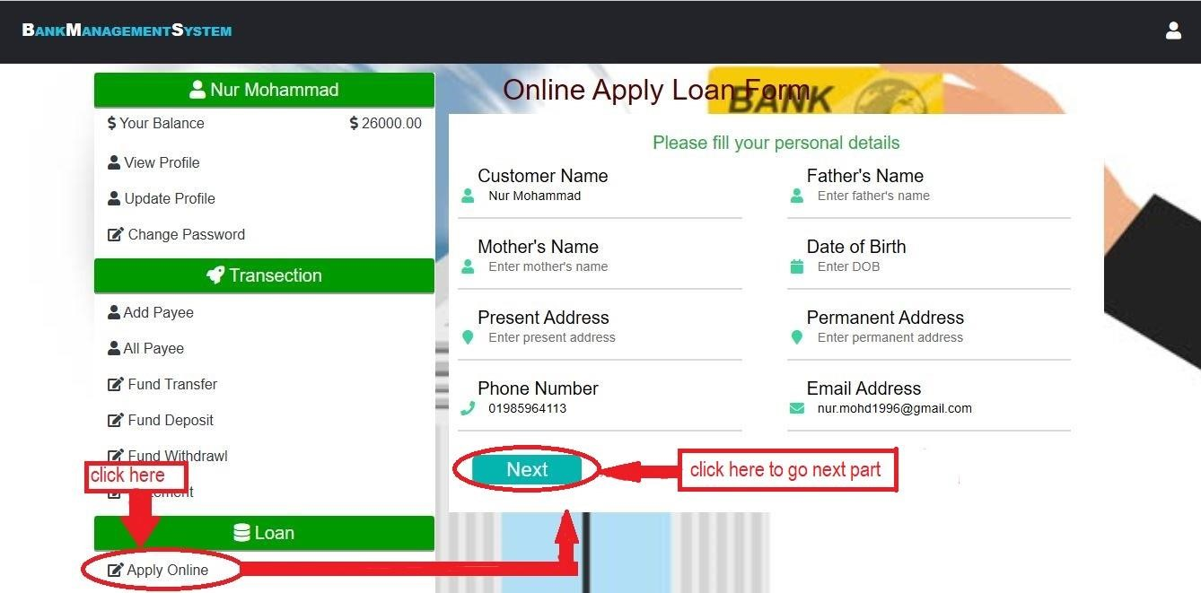

Figure 5.41: Customer loan section. (part one)

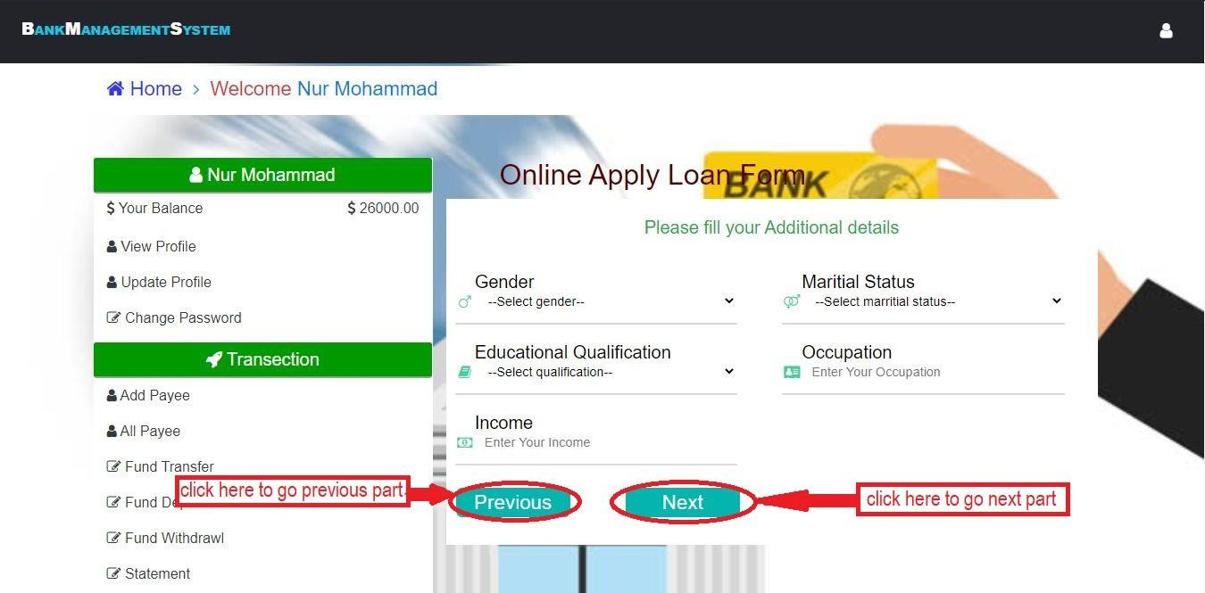

Figure 5.42 : Customer loan section. (part two)

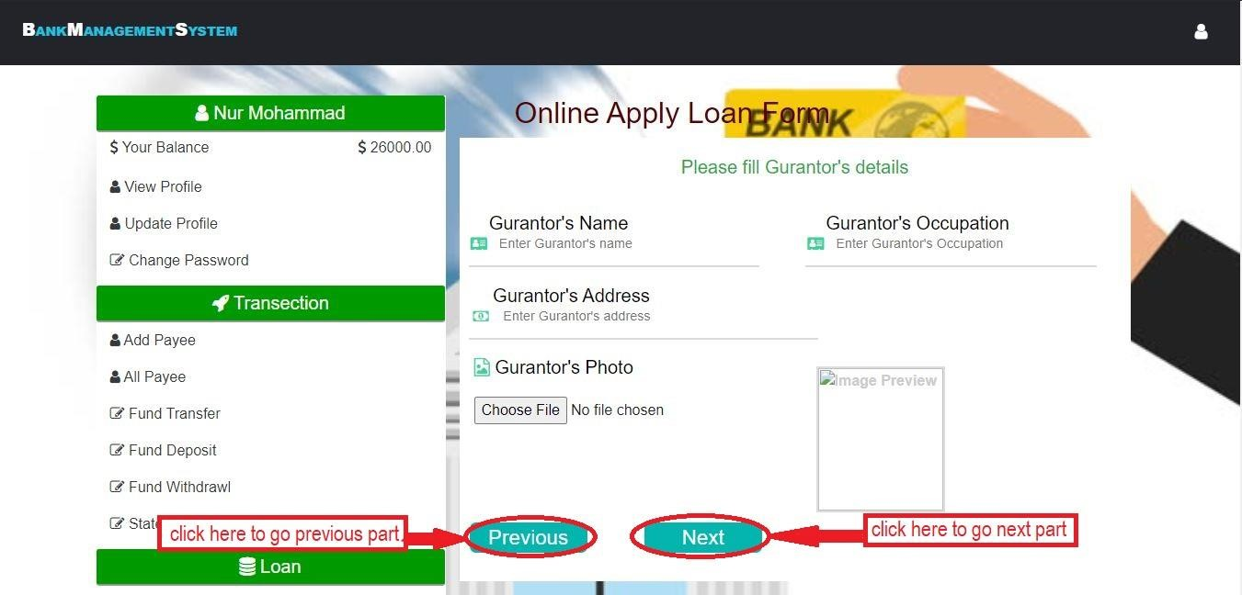

Figure 5.43 : Customer loan section. (part three)

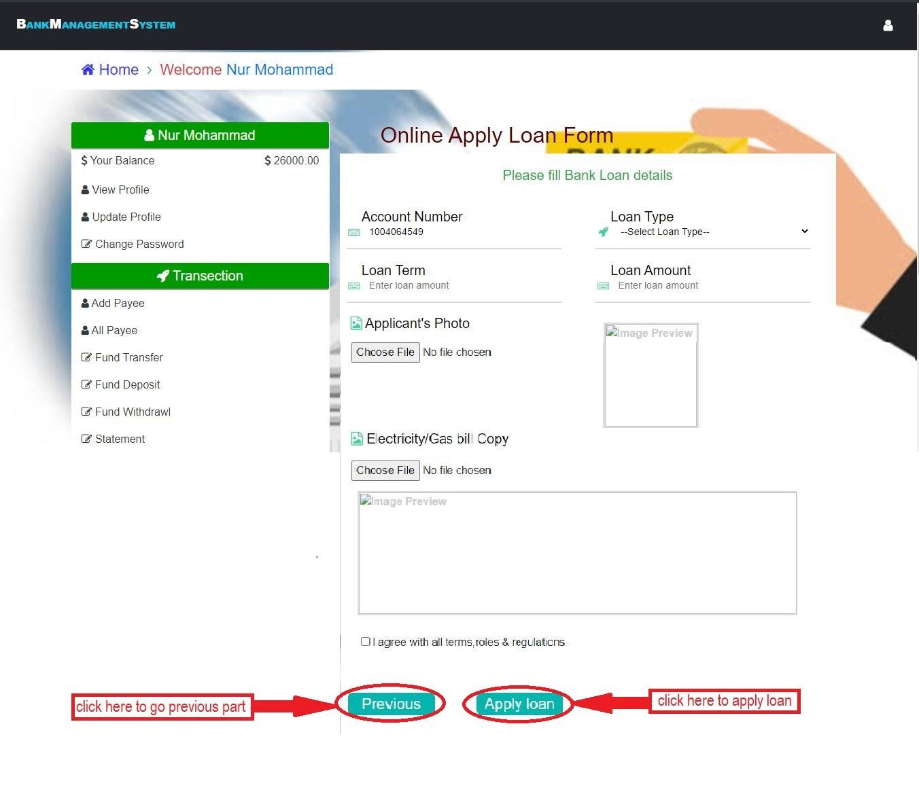

Figure 5.44 : Customer loan section. (part four)

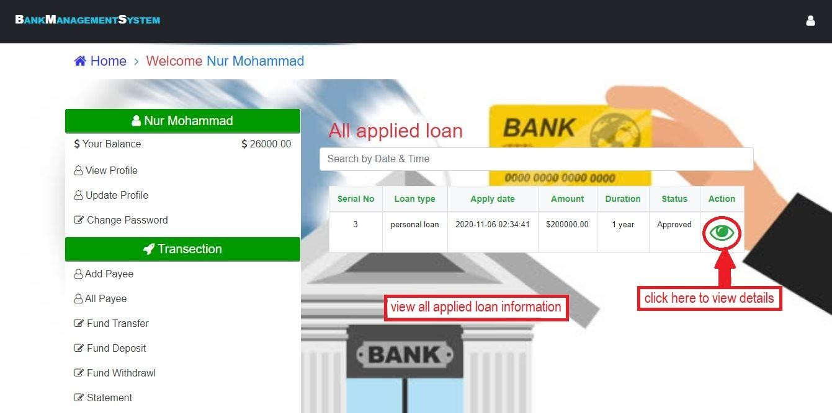

Figure 5.45 : view applied loan details.

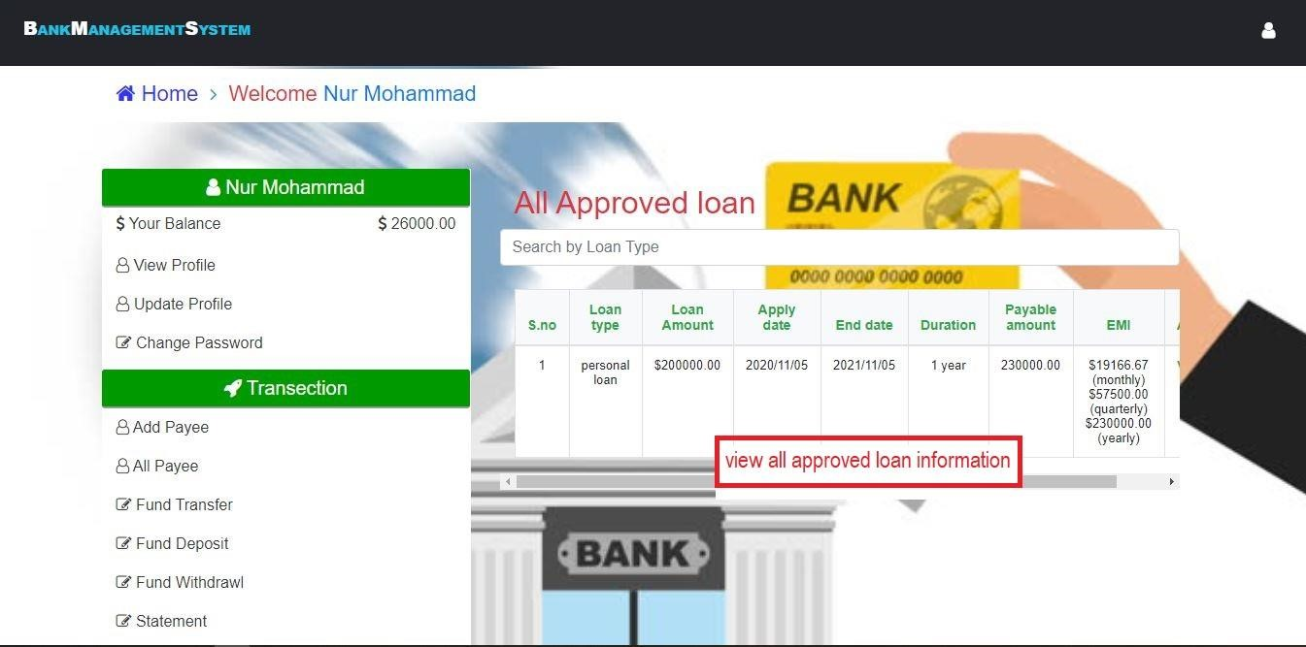

Figure 5.46 : view approved loan details.

###### 5.3.8 Customer profile update

If customers want to change their profile they can do it. After logged into their accounts a user icon will be shown at the right top or in left sidebar have update profile. After clicking this icon there will be displayed some option such as profile, change password and logout. Click the profile button to update your profile. This procedures is shown in below in figure 5.47

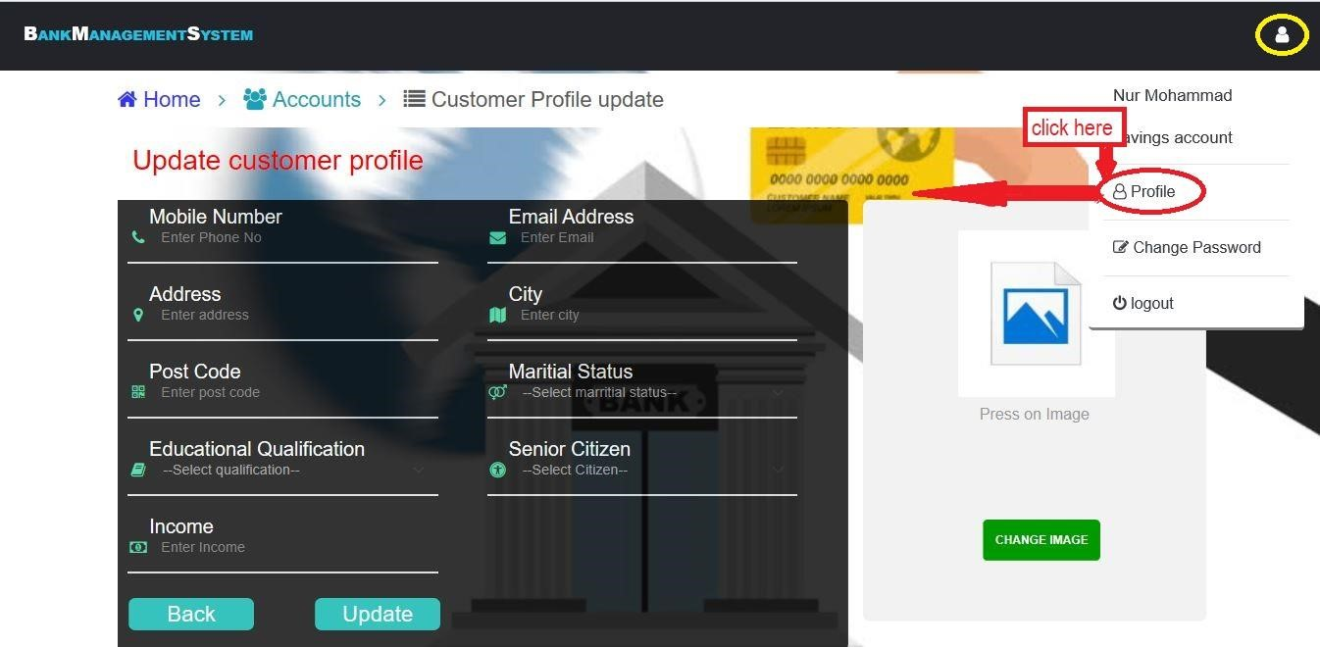

Figure 5.47 : Customer profile update form.

###### 5.3.9 Password change and logout from customer account

If customers want to change their login password they can do it. After logged into their accounts a user icon will be shown at the right top. After clicking this icon there will be displayed some option such as profile, change password and logout. Click the button which name is change password to change your login password. And logout from their accounts using session destroy.

Those procedures are shown in below (figure 5.48 and 5.49)-

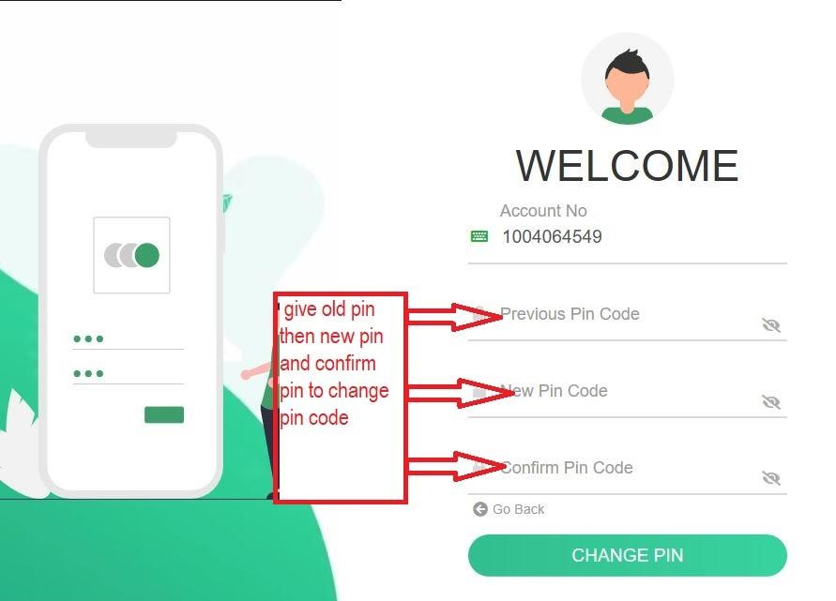

Figure 5.48 : Customer login password change

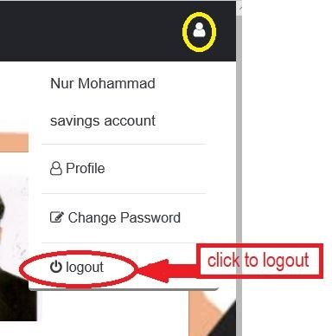

Figure 5.49: Customer logout form account.

### Chapter Six

**Result and Discussion**

The goal of the banking management system is to customer's satisfaction, the efficiency of banking transactions. The bank Management System started as a project is predicated on related with the term of technologies. The most aim of this project is to develop software for bank Management System. This project has been developed to hold out the processes easily and quickly, which isn't possible with the manuals systems, which are overcome by this software. The procedure for the result this screen is planned in such a way that the data entry, status calculation functionality, saving and quitting operations are tested in terms of sql query. This is the process which is performed on an application when it is being executed. This process is defined as a strategic document which describes the procedure of how to perform various testing on the total application in the most efficient way. The result section is described in below step by step using all flowchart-

#### 6.1 Output of this system

##### 6.1.1 Flowchart of admin login section

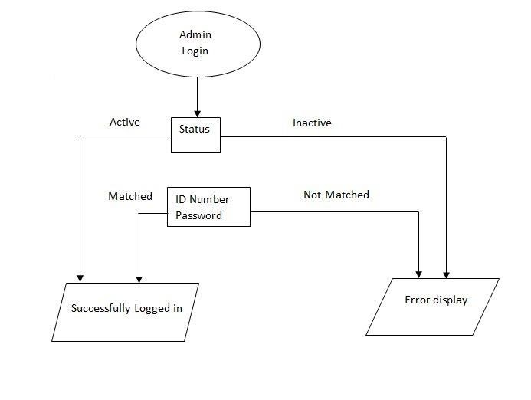

Figure 6.1: admin login flowchart

For admin login first of all admin needs to open an account. By opening account admin will get a ID number and a password. And an email will be sent to his/her account to verify the account.

By verifying account through email the status in database will be active. Otherwise it will be inactive. Now when admin will go for login first of all in a box ID number and password will be asked. If status is active and ID number and password matched with database only then admin can login successfully. Otherwise an error display will be occurred. This process is shown on above flowchart in figure 6.1

##### 6.1.2 Flowchart of Accounts module (in admin part)

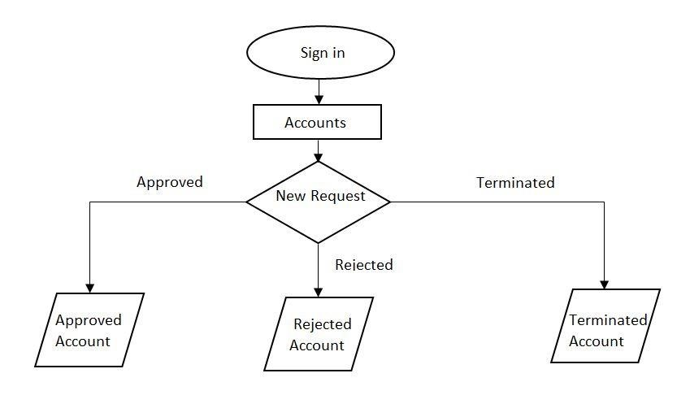

Figure 6.2: Accounts section flowchart

When bank will get the new account request then the inserted data will appear in new account request module, when an employee approved any account this data will appear in approved account module, if it is rejected then it will appear in rejected account module and if it is terminated then it will appear in terminated account module. This process is shown on above flowchart (figure 6.2).

##### 6.1.3 Admin loan section flowchart

When bank will get the new loan request then the inserted data will appear in loan request module, when an employee sanctioned any loan application this data will appear in active loan module, if it is rejected then it will appear in loan request module. This process is shown flowchart in below (figure 6.3).

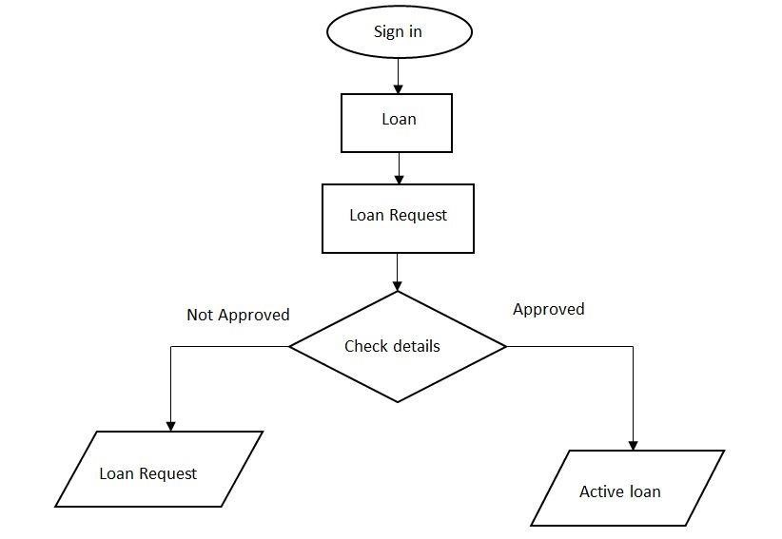

Figure 6.3: loan application procedure.

**6.1.4 Employee’s Card module flowchart (in admin part)**

When bank will get the new card request then the inserted data will appear in card request module, when an employee approved any card application this confirmation message sent to customer’s email to receive card and this data will appear in all card module. This process is shown flowchart in below (figure 6.4).

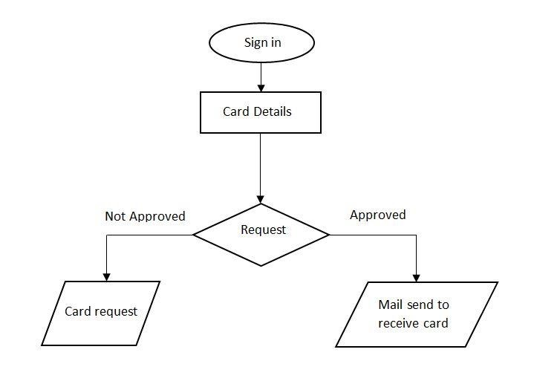

Figure 6.4: card application flowchart.

##### 6.1.5 All transaction flowcharts (in admin part)

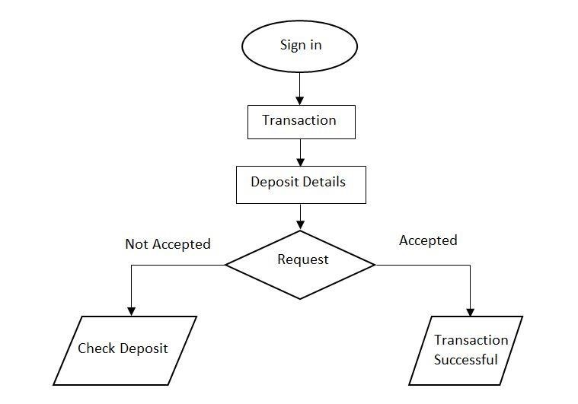

Figure 6.5: deposit fund flowchart.

After seeing all the details provided by the customer admin will decide to approve the deposit request or to remain it pending. By approving it transaction will be successful and fund will be deposit to the customer’s account. Deposit process is shown on above flowchart in figure 6.5

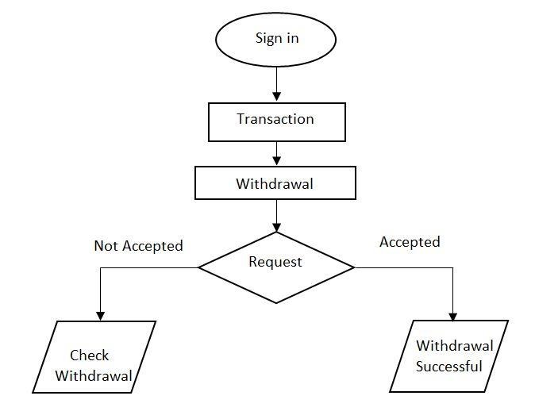

Figure 6.6: withdrawal fund flowchart.

By seeing the request admin will view all the details provided by the customer. By accepted the request withdrawal will be successful which will be shown to the customer account. And by not accepting it the request will remain pending. Withdrawal process is shown on above flowchart in figure 6.6

##### 6.1.6 Customer Login flowchart

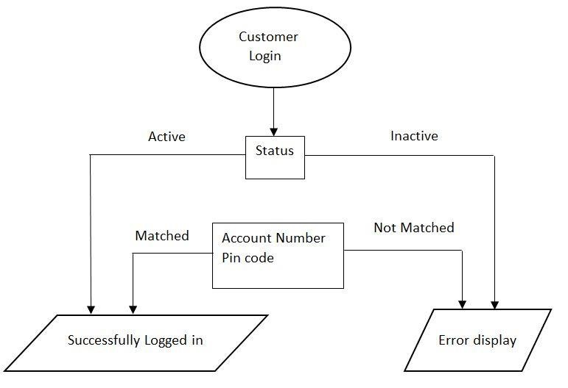

Figure 6.7: customer login flowchart.

For customer login first of all he/she needs to open an account. By opening account customer will get an Account number and a password. And admin need to approve his/her account to make the status active in database. Otherwise it will be inactive. Now when customer will go for login first of all in a box Account number and password will be asked. If status is active and Account number and password matched with database only then customer can login successfully. Otherwise an error display will be occurred. This process is shown on above flowchart in figure 6.7

##### 6.1.7 Customer Deposit fund flowchart

In customer deposit section, customer will sign in to his/her account. Then will go for ‘Fund Deposit’ section. Then a form will be shown in which customer needs to give some information like ‘Customer Name’ ‘Branch’ ‘Account Number’ ‘Term’ ‘Amount’. After filling this form if all information is valid then deposit will be successful and if there is any invalid information then an error display will occur. This process is shown in flowchart in below (figure 6.8)

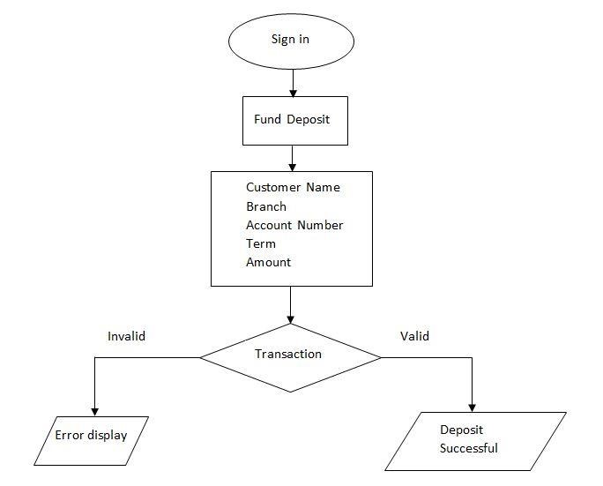

Figure 6.8: Customer deposit fund flowchart

##### 6.1.8 Customer Transfer fund flowchart

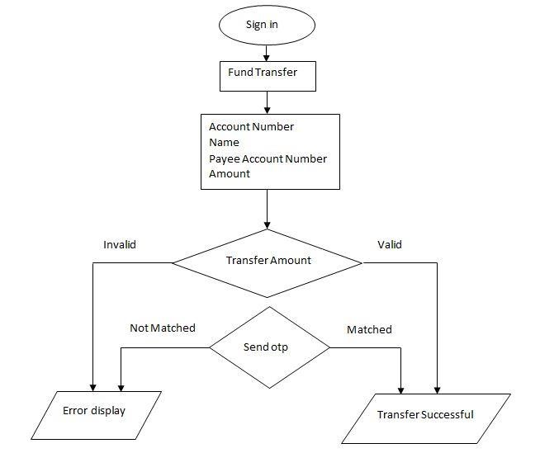

Figure 6.9: Customer transfer fund flowchart.

For customer fund transfer flowchart customer needs to sign in to his/her account. Then in ‘Fund

Transfer’ section some information will be asked to the customer like ‘Account Number’ ‘Name’ ‘Payee Account Number’ & ‘Amount’. After giving all information correctly customer needs to click on the final button ‘Transfer Amount’. Then an otp code will be sent to the customer mobile number. After giving that number database will check if the given information is valid or not and the otp code is matched or not. If yes then transfer will be successful otherwise error display will occur. This process is shown on above flowchart (figure 6.9)-

##### 6.1.10 Customer Withdrawal fund flowchart

For customer withdrawal part customer needs to sign in to his/her account. Then in fund withdrawal section some information is needed like ‘Customer Name’ ‘Branch’ ‘Account Number’ ‘Phone Number’ ‘Amount’. After this transaction if all information is valid then request will be submitted successfully. By giving any invalid information error display will be occurred. This process is shown in below (figure 6.10)-

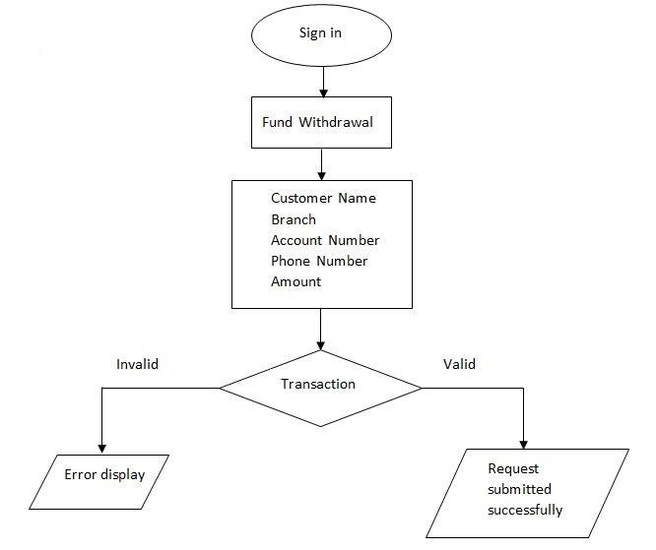

Figure 6.10: Customer withdrawal fund flowchart

#### 6.2 Benefits of online banking

Many of us lead busy lives. Some of us are up before the crack of dawn, getting ourselves prepared so we can in turn get our families ready for the day. We rush to work, rush to get the kids to school, and at the end of the day we rush home only to brace ourselves for the next day. After a hectic day, the last thing you want to do is spend time waiting in line at the bank, or even the post office. That's where Online Banking comes in. Many of the benefits of doing our banking online are obvious:

* You don't have to wait in line.
* You don't have to plan your day around the bank's hours.
* You can look at your balance whenever you want, not just when you get a statement.

There are some hidden benefits too. As a young bank customer, you're just learning how to manage your money and observe your spending patterns.

* Online banking allows you to watch your money on a daily basis if you want to. By keeping close tabs on your funds, you'll always be aware of what's happening in your bank account.
* For those experienced spenders, this option is far more appealing than the sudden discovery that you're broke!
* It's also helpful to watch how much interest you're gathering on investments and savings or what service charges you have incurred.

##### 6.2.1 Most available benefits

1. Online banking with key bank is fast, secure, convenient and free.
2. Quick, simple, authenticated access to accounts via the web application.
3. Simply scalable to grow with changing system requirement.
4. Global enterprise wide access to information.
5. Improved data security, restricting unauthorized access.
6. Minimize Storage Space.

**Chapter seven**

### Conclusion

According to the user's requirements this project is designed and implemented through many researches works. Nowadays we all are busy in work and don’t want to spend time in big line in bank. That’s why banking management system developed so that user can easily done their necessary task that taking place in a bank sitting at home or another place through mobile, laptop or other devices. Customer can easily open account (online) by following some steps and we also offer account verification services through email, mobile phone number (OTP). All advance systems added to this project for user like cash deposit, withdraw and transfer.in this paper all the tasks are described properly. This project will be more updated in future. We will develop transaction system like transfer money to other bank, pay bills and many more based on customer demand. We will try to open more branches and ATM machines outside. Moreover, we want to develop a mobile app for bms that help to do all the task only sign in using Account number. By aware of the benefits and uses of this website to the customer any bank can offer online banking system.

The “Banking Online System is a big and ambitious project. I am thankful for being provided this great opportunity to work on it. As already mentioned, this project has gone through extensive research work. On the basis of the research work, we have successfully designed and implemented banking online System. To know what the future of online banking looks like, it’s probably worth looking at the present – online banking isn’t new. When you think of online banking, you probably think about a computer (either a desktop or laptop), a three or four step security process and then an interface that lets you view the balance of your various bank accounts and credit cards, whilst permitting you to transfer money and pay bills. And you’re not wrong either. The most valuable future looks are following below:

 

* More branches of the bank, maybe it will be international, that means more ATM machines outside.
* Customer issues development based on their needs, so the help desk will be aware of their needs and easy to use.
* Developing a mobile App for banking system that help users to do the obtained his operations without go to the bank only he need to sign in using his A/C NO. And password and then use your own PIN. Finally the system will update automatically.

In this manner banking management system is completed practically and successfully.

**References**

1. Article: **Online banking**, online access:

<https://en.wikipedia.org/wiki/Online_banking>

1. Online Bank Management System,

online access: [http://www.slideshare.net](http://www.slideshare.net/) (Collect some info for report documents)

1. Banking review, online access: <https://www.essaysauce.com/>, <https://link.springer.com/chapter/10.1057%2F9781137518415_2>

1. An Empirical Research on Performance Management System, online access:

[http://etd.uum.edu.my/3017/,](http://etd.uum.edu.my/3017/)<http://macrothink.org/journal/index.php/jpag/article/view/6869>

1. Software model description, online access: [https://www.tutorialspoint.com/sdlc/sdlc_waterfall_model.htm,](https://www.tutorialspoint.com/sdlc/sdlc_waterfall_model.htm)

[https://www.geeksforgeeks.org/software-engineering-classical-waterfall-model/,](https://www.geeksforgeeks.org/software-engineering-classical-waterfall-model/) <https://www.toolsqa.com/software-testing/waterfall-model/>

1. Ghezzi, C.. Jayazeri, M. & Mandrioli, D. (1998), Fundamental of Software Engineering, 2nd Edition, Prentice-Hall.

1. Get developing and designing idea, online access:

<https://www.lovelycoding.org/banking-management-system/>

1. Design and development, online access: [http://www.ijstr.org/final-print/aug2015/Bank-Customers-Management-System.pdf,](http://www.ijstr.org/final-print/aug2015/Bank-Customers-Management-System.pdf)  [https://www.projecttopics.org/design-implementation-bank-management-system.html,](https://www.projecttopics.org/design-implementation-bank-management-system.html) <https://iopscience.iop.org/article/10.1088/1742-6596/1015/4/042023/pdf>

1. Use case diagram, online access: [https://www.tutorialspoint.com/uml/uml_use_case_diagram.htm,](https://www.tutorialspoint.com/uml/uml_use_case_diagram.htm)

<https://www.freeprojectz.com/use-case/banking-management-system-use-case-diagram>

1. Database design toolkits, online access: [http://localhost/phpmyadmin/,](http://localhost/phpmyadmin/) [http://www.w3schools.com](http://www.w3schools.com/)

1. Learning MYSQL, JavaScript, jQuery, PHP, HTML, CSS, BOOTSTRAP, online access:

[http://www.w3schools.com,](http://www.w3schools.com/)  [https://getbootstrap.com/,](https://getbootstrap.com/) [https://github.com/,](https://github.com/) [http://www.youtube.com](http://www.youtube.com/)

1. PHP and MySQL video tutorials, online access: [http://www.freebanglatutorial.com,](http://www.freebanglatutorial.com/) [http://www.youtube.com,](http://www.youtube.com/) [http://www.w3schools.com](http://www.w3schools.com/)  [13] JavaScript validation for empty input field, online access: <http://stackoverflow.com/questions/3937513/javascript-validation-for-empty-input-field>

[14] JavaScript form validation: Validate **Password**, Validate **Email**, Validate **Phone Number**, online access: [http://webcheatsheet.com/javascript/form_validation.php,](http://webcheatsheet.com/javascript/form_validation.php) [http://www.w3schools.com](http://www.w3schools.com/)

**The End**